

GOVERNMENT OF INDIA

**MINISTRY OF SKILL DEVELOPMENT & ENTREPRENEURSHIP**

DIRECTORATE GENERAL OF TRAINING

**NATIONAL SKILL TRAINING INSTITUTE**

NSTI (W) SALTLAKE KOLKATA

# CERTIFICATE

This is to certify that following trainees have completed their project titled

**“NSTI Smart Cloud Campus”**

**For IBM Program – IT, Networking and Cloud (Technical Diploma)**

|  |  |
| --- | --- |
| **ROLL NO** | **NAME** |
| ADIT19AU03683 | PUSHPA KUMARI |

|  |  |  |
| --- | --- | --- |
| Miss.Arpita Roy | Mr. K.L Kuli Mr. Ramamurthy | Mr. Sarbojit Neogi |
| IBM Faculty | ADIT Director Head of office/Principal | Section In-charge |

## ACKNOWLEDGEMENT

We would like to express my sincere gratitude to several individuals and organizations for supporting me throughout my diploma study. First, I wish to express my sincere gratitude to my trainer, Mr. Boddu Lingaiah and Miss Arpita Roy, for Their enthusiasm, patience, insightful comments, helpful information, practical advice and unceasing ideas that have helped me tremendously at all times in my study and writing of this project report. His immense knowledge, profound experience and professional expertise in computer science has enabled me to complete this project successfully.

I also wish to express my sincere thanks to the National Skill Training Institute, Salt Lake

Kolkata for accepting me into the diploma program. In addition, I am deeply indebted to the Ministry of Skill Development & Entrepreneurship and IBM for granting me the diploma course. This technical and financial support has enabled me to complete my diploma course studies successfully. Also, I am grateful the Mr. Boddu Lingaiah faculty of NSTI(W) Salt Lake Kolkata for supporting me for course completion in the specific subject.

I am also grateful to the following NSTI Regional Director Mr. K.L Kuli and Principal of

NSTI(W)Salt Lake Kolkata -G.C Ramamurthy for their consistent support.



## ABSTRACT



The physical classroom learning nowadays is no longer applicable for the current younger generations. Internet and distance learning which is generally known as online education plays a vital role in the country’s education system. It is undeniable that online education provides ample of benefits to young learners. Nevertheless, there are also many negative implications from online education. Limited collaborative learning, increase in time and effort are the several negative implications from online education. This study examines the implications of online education among students especially in a private higher learning institution and its effect towards Malaysian national education system. Information has been collected through surveys, interviews and together with secondary data, and were analysed using SPSS. The studies found that there are various serious issues regarding online education and on its effect on the quality of Malaysian Education System to certain extend. Several problems have been identified and these issues have to be solved in order to sustain the quality of education for future generations. Furthermore, Ministry of Higher Education should formulate a standard policy, monitor closely the implementation of online education, evaluate and review the method used in teaching and upgrade to maintain the quality of online education in private higher education institution.



**INDEX**

|  |  |  |
| --- | --- | --- |
| **SI. No.** | **Table of Contents** | **Page No.** |
| 1 | Chapter 1: Introduction | 1-4 |
| 2 | Chapter 2: Services and Tools Required | 5-8 |
| 3 | Chapter 3: Project Architecture | 9 |
| 4 | Chapter 4: Architecture Blocks Detail Working | 10 |
| 5 | Chapter 5 how to create a webpage and deploy it IBM Bluemix | 11-23 |
| 5.1 | create a dynamic web Project | 11-12 |
| 5.2 | create files inside Dynamic Web project | 12-15 |
| 5.3 | Add IBM Bluemix Server with webpage | 15-21 |
| 5.4 | Run application on cloud | 21-22 |
| 6 | Source code | 23-97 |
| 7 | Screenshots | 98-101 |
| 8 | Conclusion | 102 |
| 9 | References | 103 |



**CHAPTER 1**

**INTRODUCTION**

**1.1 Overview**

**1.2 Feature**

**1.3 Advantages**

**1.4 Scope**

**1.5 Future Work**

# INTRODUCTION

## 1.1 Overview

The system will hopefully serve as a centralized database of syllabus for the courses offered at the university allowing students and faculties (current, past and prospective), to view them. The system will end up bringing an effective communication among students, lectures, and the administration, by accessing information and other resources anytime, anywhere.

Here are some expected results of the project:

* Lectures to upload assignments and resources for their units.
* Students to download the resources and upload assignments.
* It provides an easy-to-use way to manage course websites that include schedule information, announcements, as well as course discussions.

### 1.2 Feature

E-Learning represents an innovative shift in the field of learning, providing rapid access to specific knowledge and information. It offers online instruction that can be delivered anytime and anywhere through a wide range of electronic learning solutions such as Web-based courseware, online discussion groups, live virtual classes, video and audio streaming, Web chat, online simulations, and virtual mentoring. E-Learning enables organizations to transcend distance and other organizational gaps by providing a cohesive virtual learning environment. Companies must educate and train vendors, employees, partners, and clients to stay competitive and E-Learning can provide such just-in-time training in a cost-effective way. Developing and deploying effective E Learning programs may require products and services supplied by a variety of vendors, leaving one to connect the dots. One way to start is to define the goals of the desired learning solution.

### 1.3 Advantages

* + - * Great transparency
      * Great accessibility
      * Easy availability of documents, transcripts, live discussions and training materials
      * Less cost
      * Opportunities to develop technological competencies
      * Access global resource and library
      * Fix time according to your suitability

### 1.4 Scope

The main purpose of education is to achieve upward mobility. Online courses certification programs have been able to provide inexpensive education to the masses and also save time, energy and money.

Electronic-learning through certified online courses provides a wide range of courses that caters to the core interests of the student, thus creating a fertile arena for future advancement.

There is a misplaced notion, that employers prefer students with traditional brick and mortar college degrees. On the contrary, corporate organizations in India are recognizing the high skill levels of students who have undergone online courses certification programs from highly acclaimed educational institutions.

### 1.5 Future Work

As our work-life changes in response to technology and world changes, we must rethink our conception of work. Cybersecurity and IoT can change our decision-making and offer new opportunities for new employees and seasoned workers. edX and partners can help you with reskilling and provide a pathway for working in the new paradigm. The Future of Work Initiative is seeking to address the obstacles faced by workers today, and the courses you take here could provide you with everything you need to thrive in the future of work.so these types of websites will highly demand in future.

**CHAPTER 2**

# SERVICES AND TOOLS REQUIRED

## 2.1 Services Used

### IBM Bluemix

Bluemix is the IBM open cloud platform that provides mobile and web developers access to IBM software for integration security transaction and other key functions as well as software from business partners.

Built on Cloud Foundry open-source technology Bluemix provides pre-built Mobile Backend as a Service capabilities. Bluemix offers more control to application developers by using its Platform as a Service (PaaS) offering. The goal is to simplify the delivery of an application by providing services that are ready for immediate use and hosting capabilities to enable internal scale development.

With the broad set of services and runtimes in Bluemix the developer gains control andflexibility and has access to various data options from predictive analytics to big data.

**Bluemix provides the following features:**

* A range of services that enable you to build and extend web and mobile apps fast
* Processing power for you to deliver app changes continuously
* Fit-for-purpose programming models and services
* Manageability of services and applications
* Optimized and elastic workloads
* Continuous availability

**2.2 Tools and Software used**

## 2.2.1 SOFTWARE SPECIFICATION: -

Operating System: - Win 7 & Higher Version

Front End: - html, Bootstrap, jQuery, CSS, JavaScript

Database: - MySQL

### 2.2.2 HARDWARE SPECIFICATION: -

Hard Disk: - 1TB Hard Disk

Processor: - Intel Core i3 & Higher Version

Memory: - 4 GB Ram

#### 2.3 JAVASCRIPT

JavaScript (JS) is a lightweight, interpreted, or just-in-time compiled programming language with first-class functions. While it is most well-known as the scripting language for Web pages, many non-browser environments also use it, such as Node.js, Apache CouchDB and Adobe Acrobat. JavaScript is a prototype-based, multi-paradigm, single-threaded, dynamic language, supporting object-oriented, imperative, and declarative (e.g., functional programming) styles. Read more about JavaScript.

This section is dedicated to the JavaScript language itself, and not the parts that are specific to Web pages or other host environments. For information about API specifics to Web pages, please see Web APIs and DOM.

# 2.4 HTML

The Hypertext Markup Language, or HTML is the standard markup language for documents designed to be displayed in a web browser. It can be assisted by technologies such as Cascading Style Sheets (CSS) and scripting languages such as JavaScript.

Web browsers receive HTML documents from a web server or from local storage and render the documents into multimedia web pages. HTML describes the structure of a web page semantically and originally included cues for the appearance of the document.

# 2.5 CSS

Cascading Style Sheets (CSS) is a style sheet language used for describing the presentation of a document written in a markup language such as HTML.

CSS is a cornerstone technology of the World Wide Web, alongside HTML and JavaScript.

CSS is designed to enable the separation of presentation and content, including layout, colors, and fonts. This separation can improve content accessibility, provide more flexibility and control in the specification of presentation characteristics, enable multiple web pages to share formatting by specifying the relevant CSS in a separate .CSS file which reduces complexity and repetition in the structural content as well as enabling the .CSS file to be cached to improve the page load speed between the pages that share the file and its formatting.

## 2.6 Eclipse

Eclipse is an integrated development environment (IDE) used in computer programming.[5] It contains a base workspace and an extensible plug-in system for customizing the environment. Eclipse is written mostly in Java and its primary use is for developing Java applications, but it may also be used to develop applications in other programming languages via plug-ins, including Ada, ABAP, C, C++, C#, Clojure, COBOL, D, Erlang, Fortran, Groovy, Haskell, JavaScript, Julia,[6] Lasso, Lua, NATURAL, Perl, PHP, Prolog, Python, R, Ruby (including Ruby on Rails framework), Rust, Scala, and Scheme. It can also be used to develop documents with LaTeX (via a TeXlipse plug-in) and packages for the software Mathematica. Development environments include the Eclipse Java development tools (JDT) for Java and Scala, Eclipse CDT for C/C++, and Eclipse PDT for PHP, among others.

### CHAPTER 3

**PROJECT ARCHITECTURE**

**3.1 Architecture**

#### USER FRONTEND BACKEND

**HTML 5 NODEJS 14.0**



#### Database

##### Architecture changes applied as per products used

















### CHAPTER 4

**ARCHITECTURE BLOCKS DETAIL WORKING**

#### 4.1 Blocks



**HOME**



**SIGN UP**



**SIGN IN**



**COURSES**



**PRICE**



**ABOUT**

# CHAPTER 5

## Create an application and deploy the application on Bluemix platform

**1. create a dynamic web Project**

## Step 1

• open eclipse

•

Go to file

•

select Dynamic web project

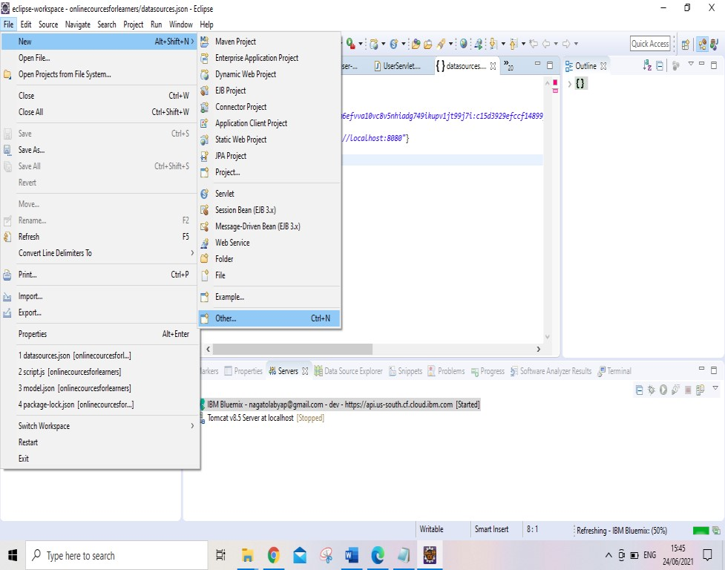

Give the project name

Click on finish

Then successfully created my Dynamic web project

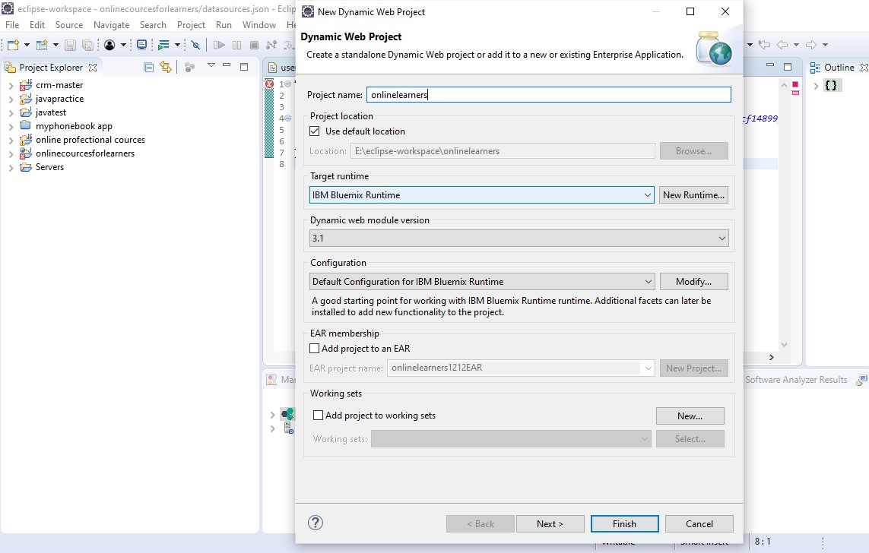

**2. create files inside Dynamic Web project I. create jsp file**

## Step 1

Go inside project

Right click on jsp

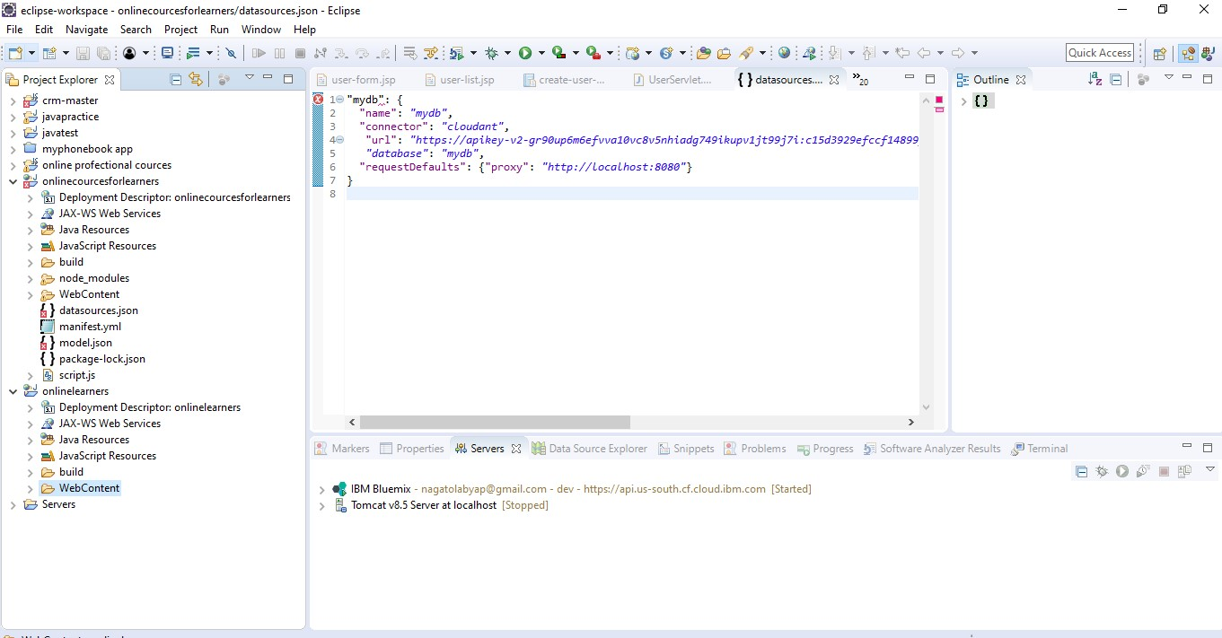

Select jsp file

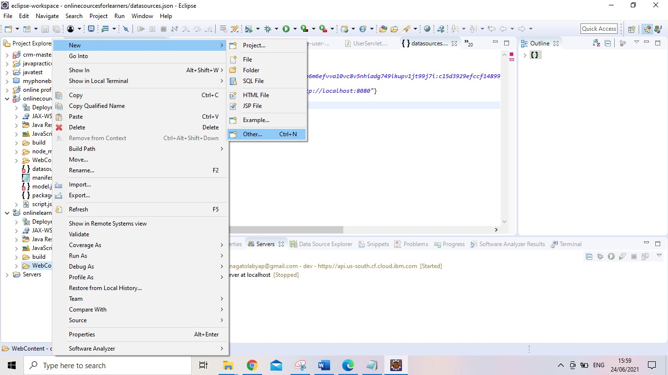

Provide the name

Click on finish

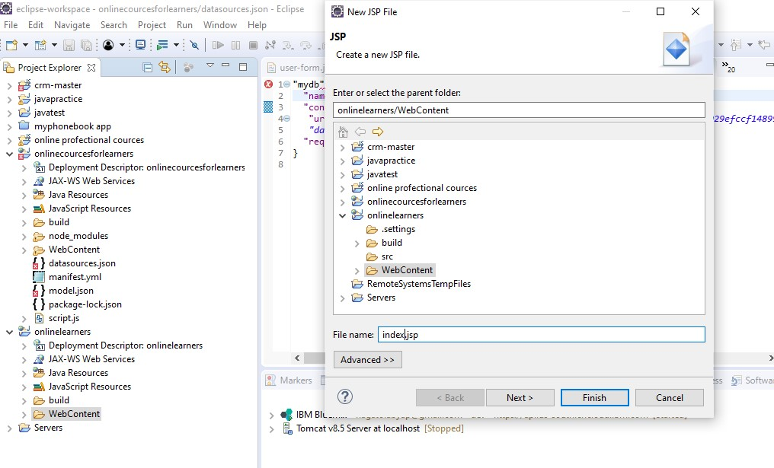

### You can see successfully created my index. Jsp file

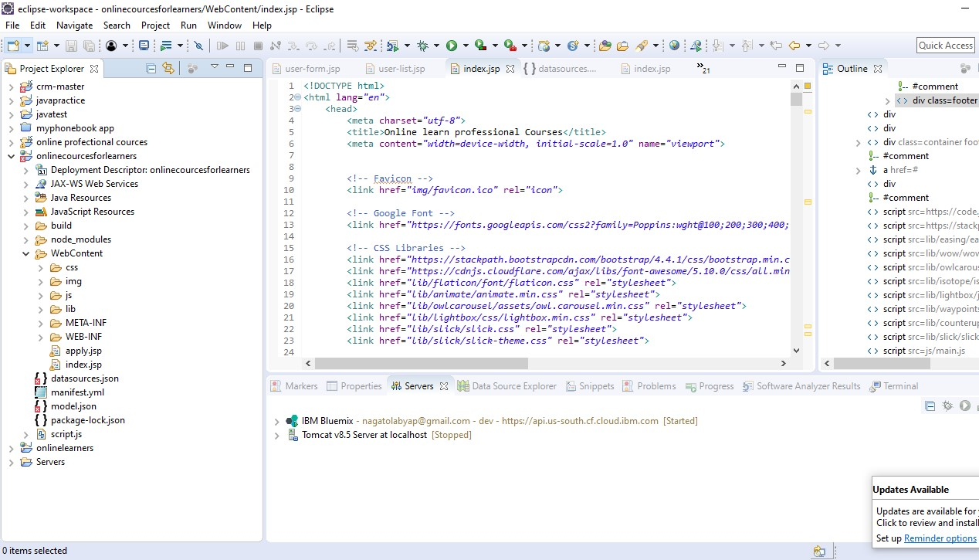

### II. create a CSS file

Right click on CSS folder

Click on other

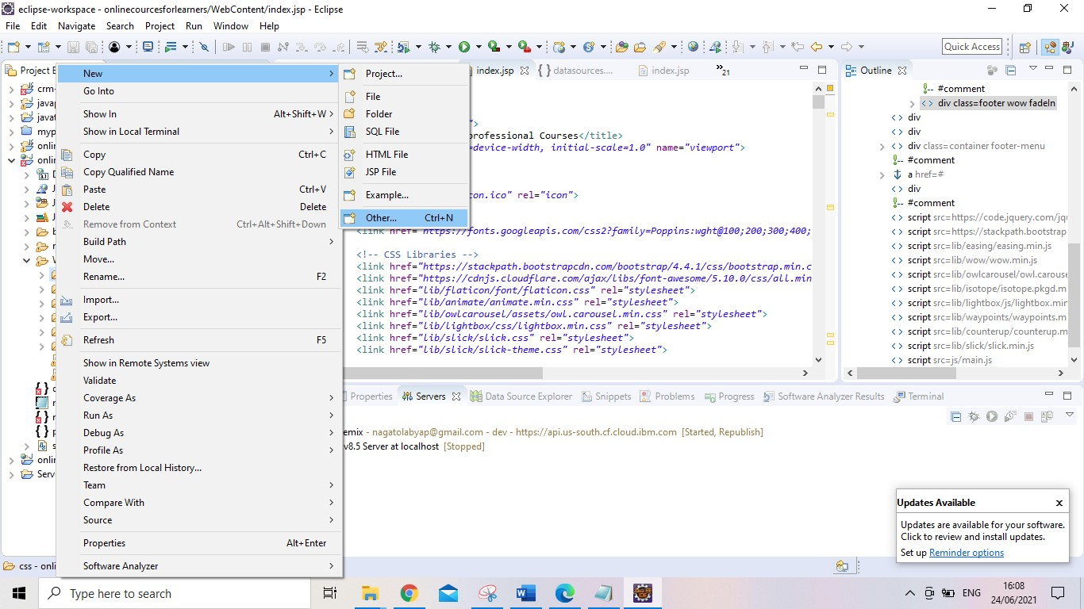

Click on CSS file

Click on next

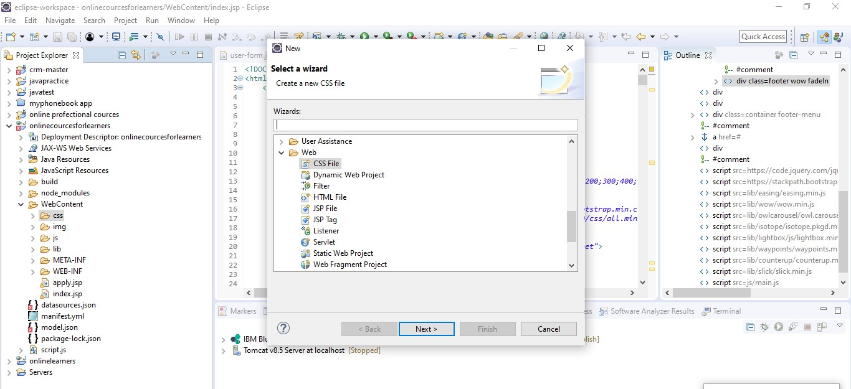

Give file name

and

click on finish

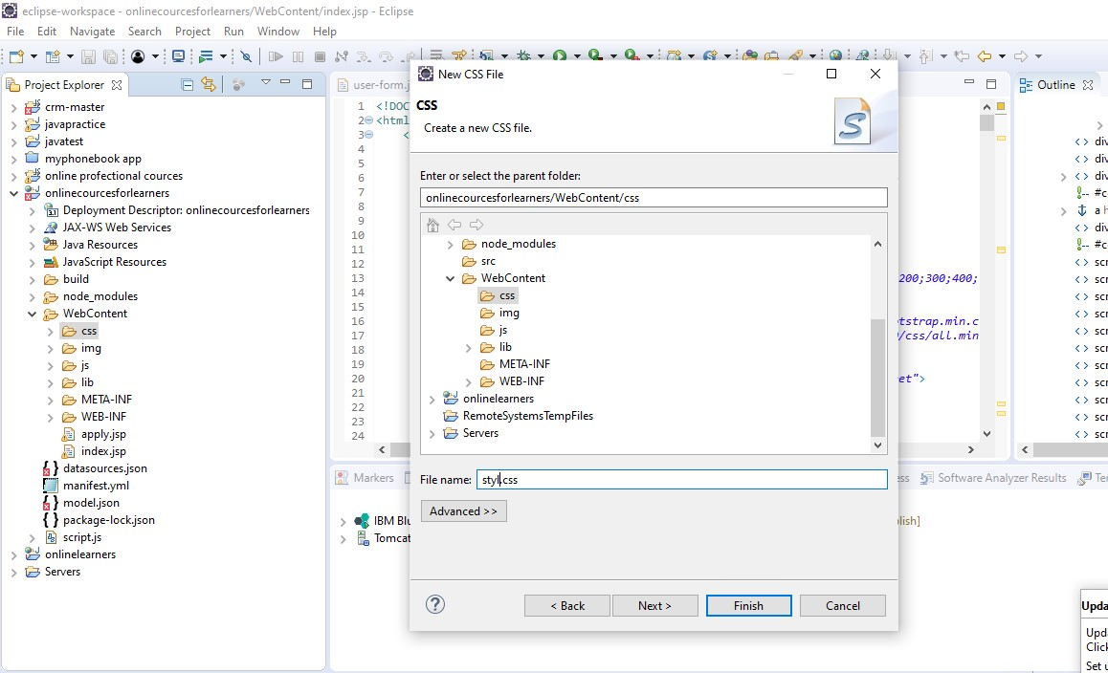

**You see in image successfully created CSS file**

### I have written CSS code

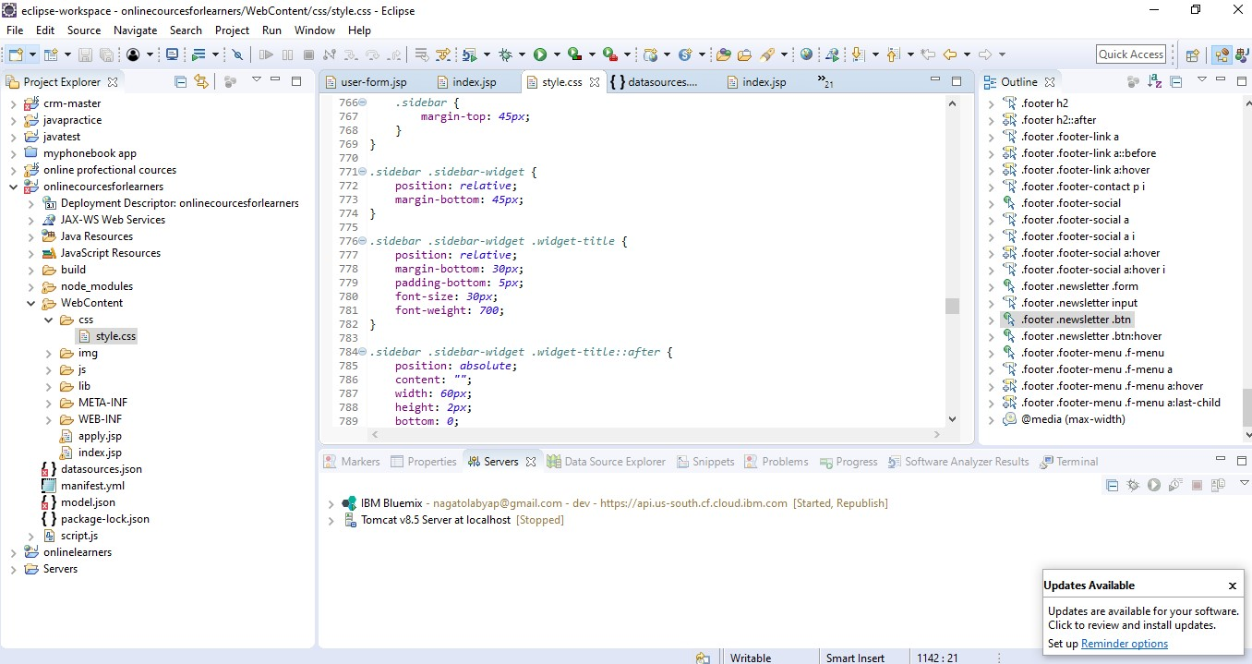

## 3. Add IBM Bluemix Server with webpage Step 1

1. Right click on server
2. Select new
3. Click on server

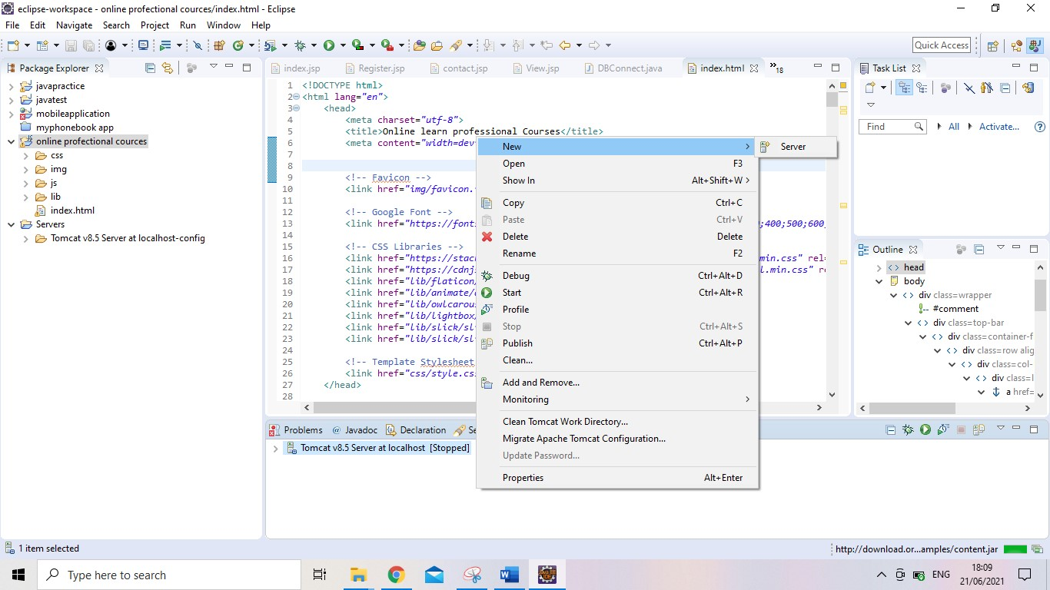

1. Select server
2. I have chosen IBM Bluemix server

6.

Click on next button

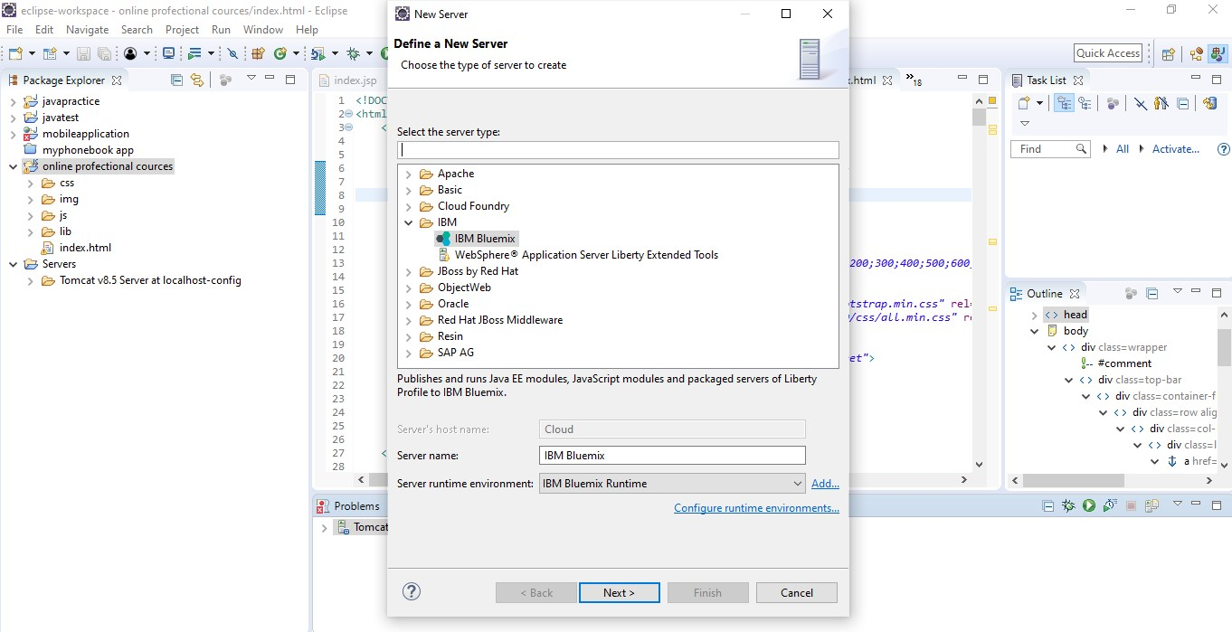

1. Provide your IBM cloud credential
2. Select the region
3. Validate account
4. Click on next button

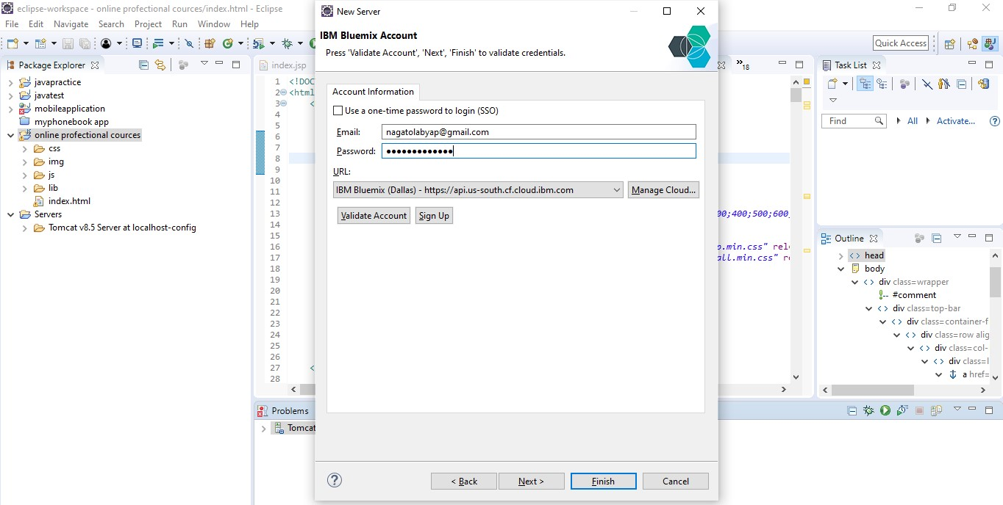

1. Select dev
2. Click on finish button

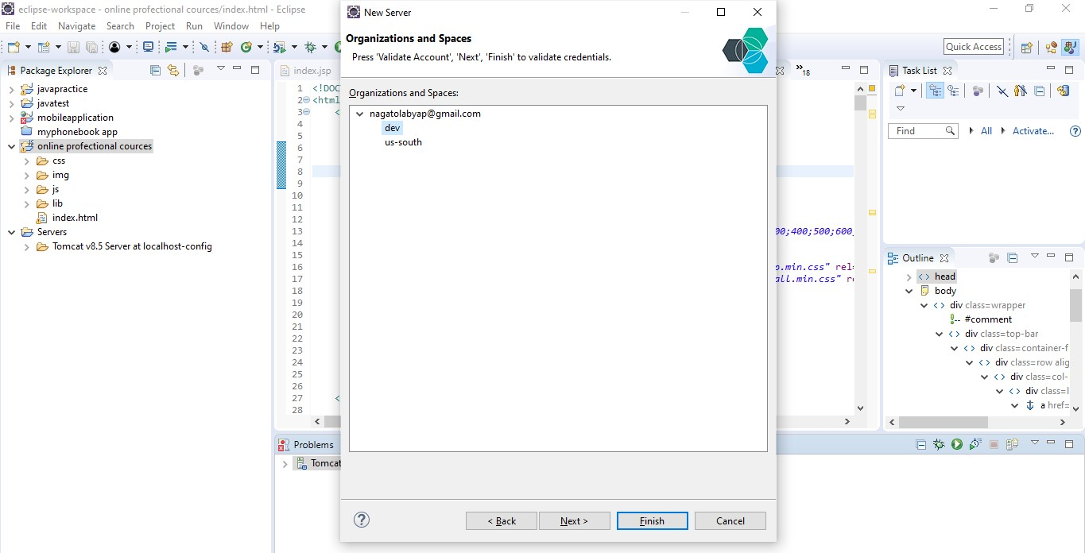

You can able to see in image connect application with cloud

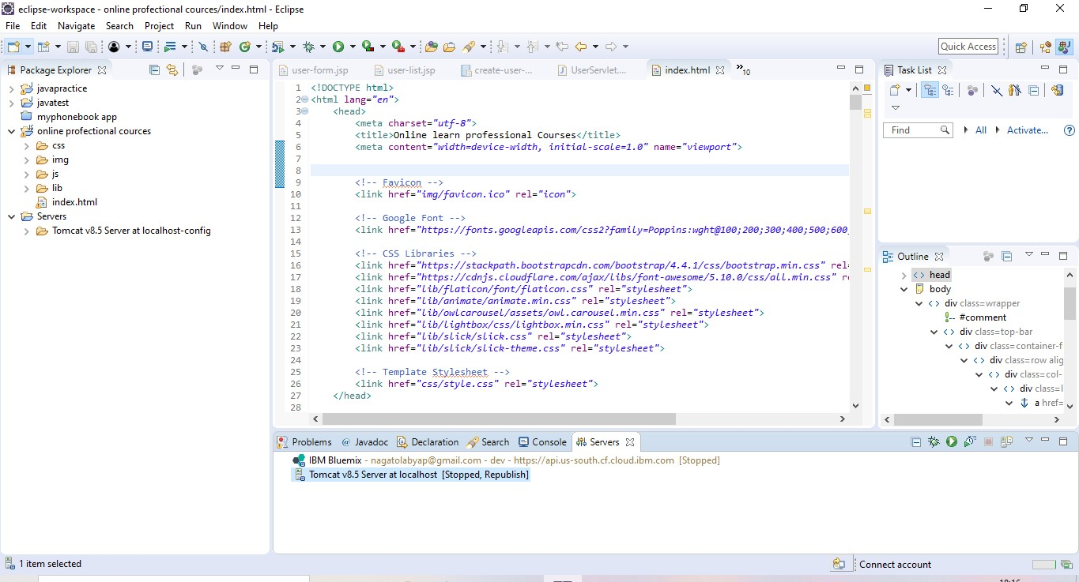

1. Right click on Bluemix server

14.

Click on publi

sh

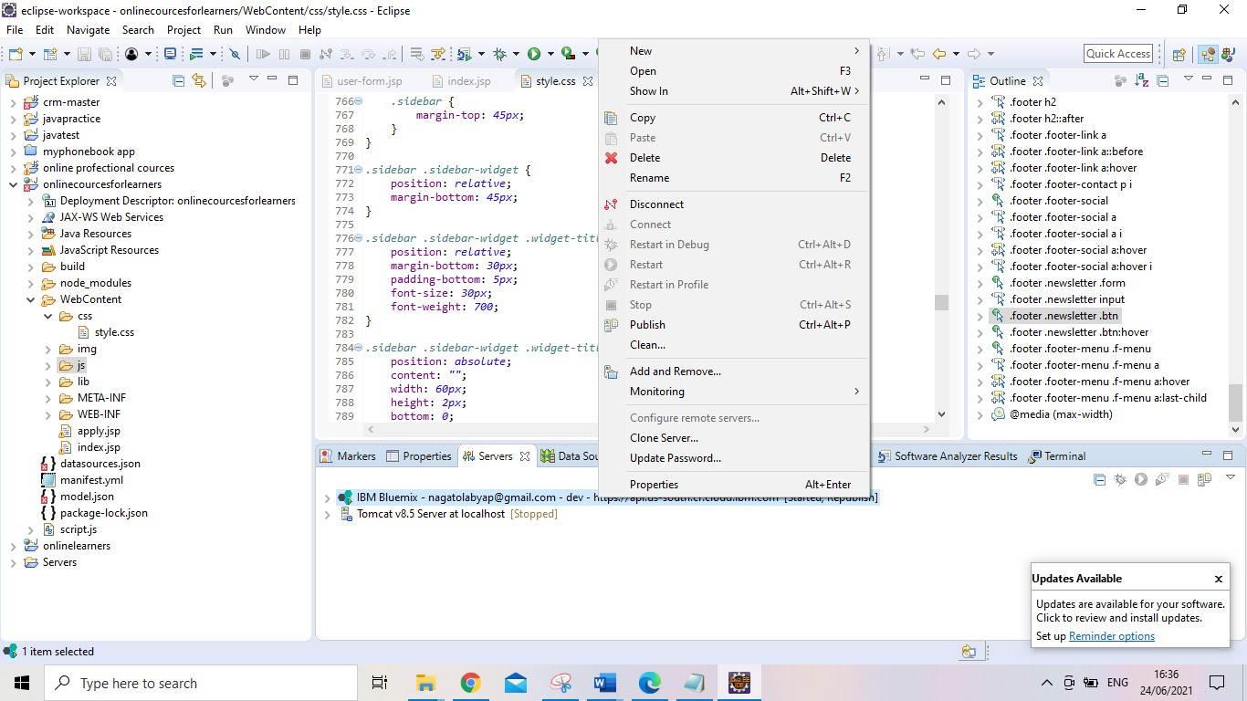

Open this page

Check on save button

Then click on next button

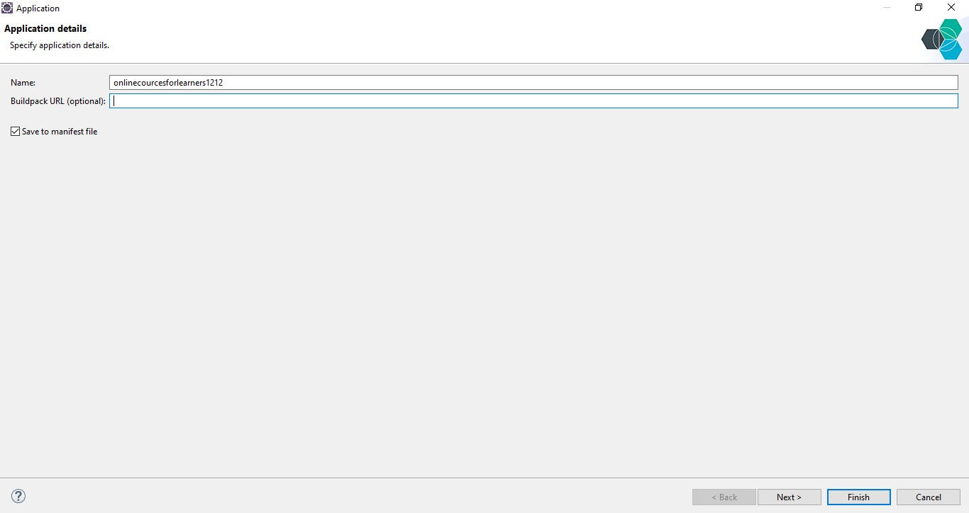

I have changed the memory limit 256

Click on finish

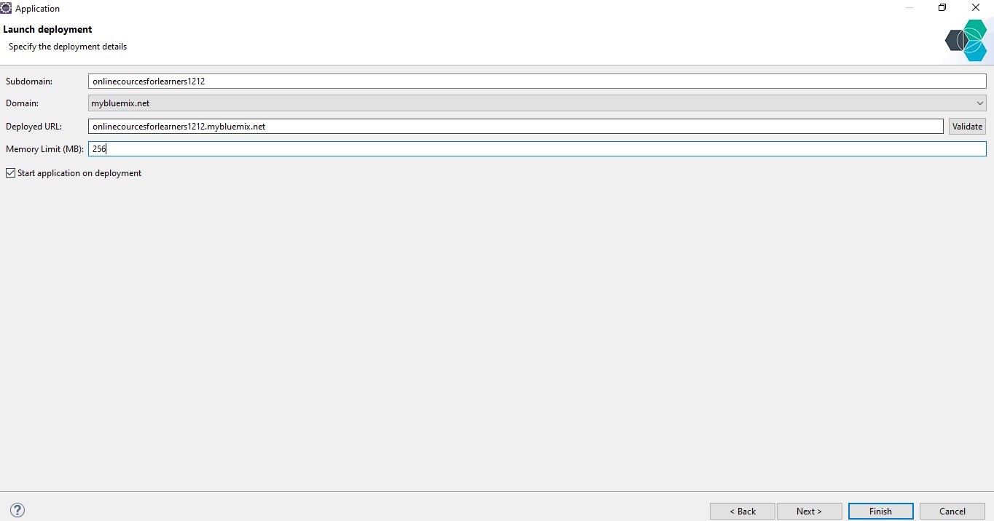

You can see in image deploying my application on IBM Bluemix server

After 10min my application deploy on IBM cloud

My application

runs

on eclipse

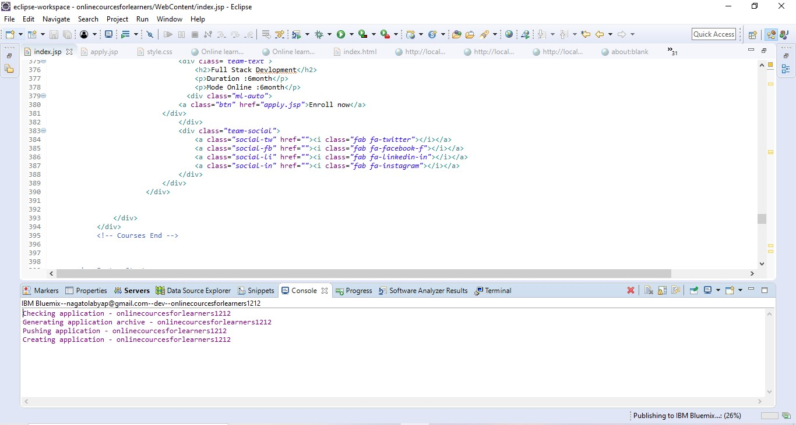

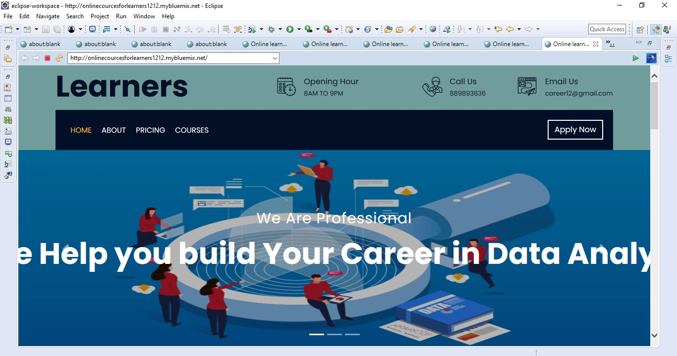

You can able to see my application successfully deploy on cloud

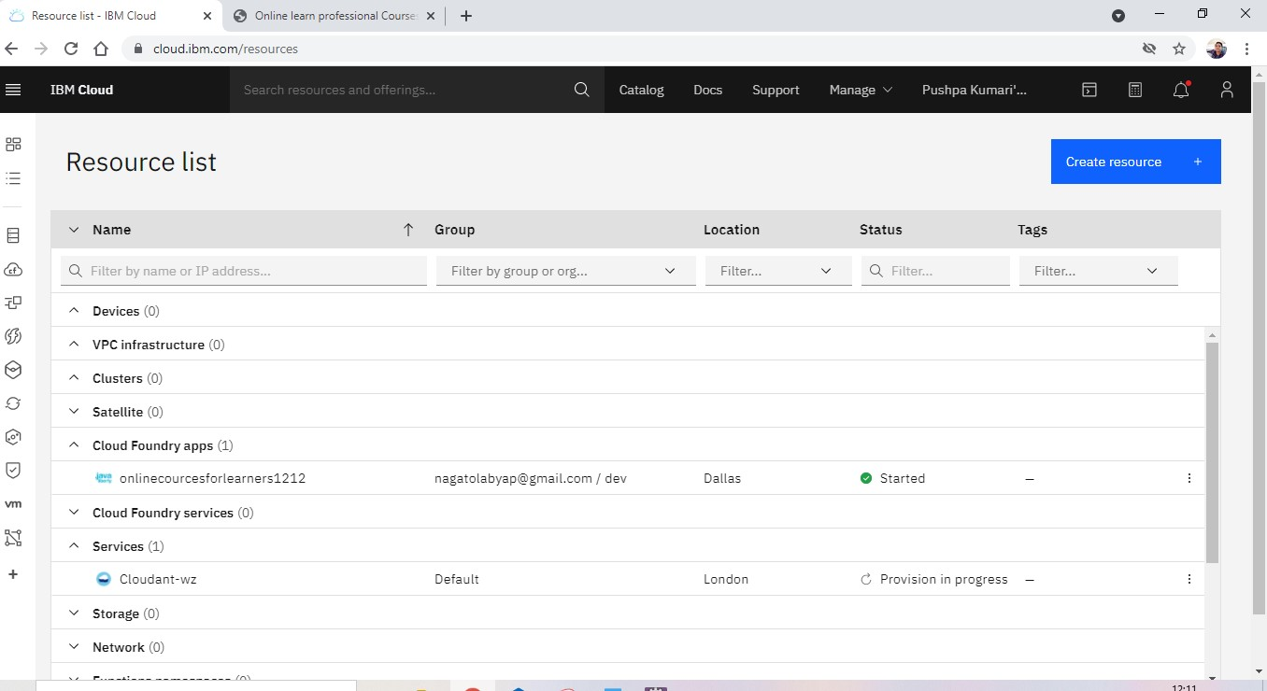

## 4. Run application on cloud

Click on cloud foundry app



Click on visit app URL

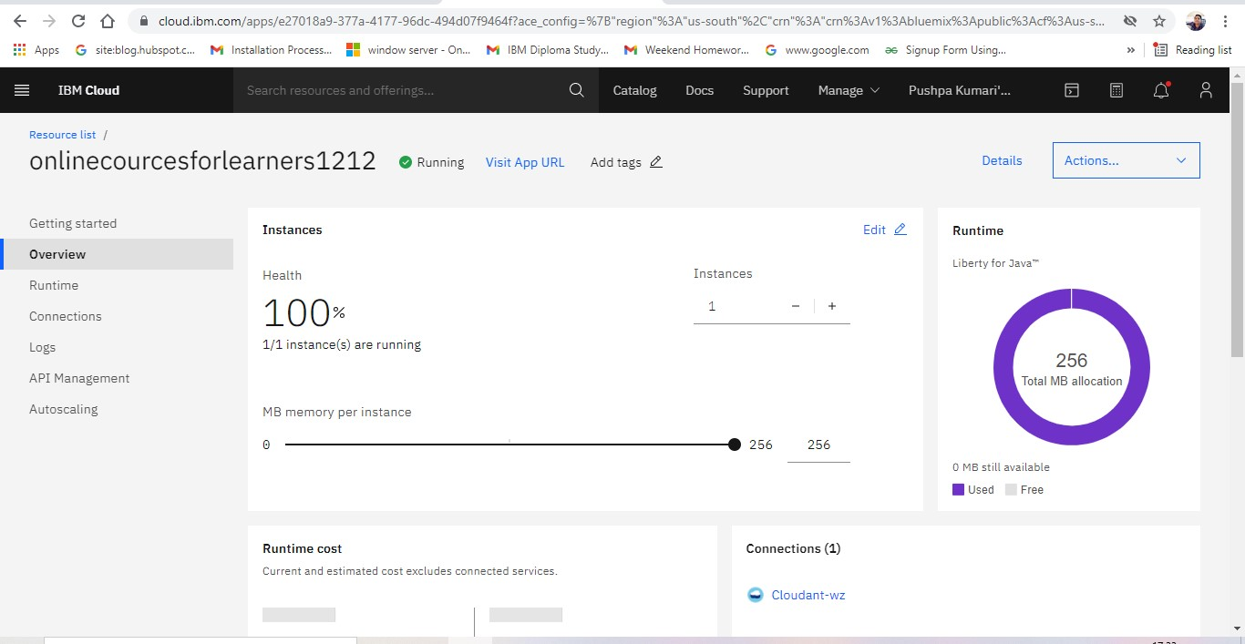

You can able to see my application is running on cloud



These are steps

Following by those steps we can create dynamic webpage and create a webpage and deploy it IBM Bluemix server

## Source code

### Index.jsp

<!DOCTYPE html>

<html lang=*"en"*>

<head>

<meta charset=*"utf-8"*>

<title>Online learn professional Courses</title>

<meta content=*"width=device-width, initial-scale=1.0"* name=*"viewport"*>

<!-- Favicon -->

<link href=*"img/favicon.ico"* rel=*"icon"*>

<!-- Google Font -->

<link

href=*"https://fonts.googleapis.com/css2?family=Poppins:wght@100;200;300;400;500;600;70 0;800;900&display=swap"* rel=*"stylesheet"*>

<!-- CSS Libraries -->

<link href=*"https://stackpath.bootstrapcdn.com/bootstrap/4.4.1/css/bootstrap.min.css"* rel=*"stylesheet"*>

<link href=*"https://cdnjs.cloudflare.com/ajax/libs/font-awesome/5.10.0/css/all.min.css"* rel=*"stylesheet"*>

<link href=*"lib/flaticon/font/flaticon.css"* rel=*"stylesheet"*>

<link href=*"lib/animate/animate.min.css"* rel=*"stylesheet"*>

<link href=*"lib/owlcarousel/assets/owl.carousel.min.css"* rel=*"stylesheet"*>

<link href=*"lib/lightbox/css/lightbox.min.css"* rel=*"stylesheet"*>

<link href=*"lib/slick/slick.css"* rel=*"stylesheet"*>

<link href=*"lib/slick/slick-theme.css"* rel=*"stylesheet"*>

<link href=*"css/style.css"* rel=*"stylesheet"*>

</head>

<body>

<div class=*"wrapper"*>

<!-- Top Bar Start -->

<div class=*"top-bar"*>

<div class=*"container-fluid"*>

<div class=*"row align-items-center"*>

<div class=*"col-lg-4 col-md-12"*>

<div class=*"logo"*>

<a href=*"index.html"*>

<h1>Learners</h1>

<!-- <img src="img/logo.jpg" alt="Logo"> -->

</a>

</div>

</div>

<div class=*"col-lg-8 col-md-7 d-none d-lg-block"*>

<div class=*"row"*>

<div class=*"col-4"*>

<div class=*"top-bar-item"*>

<div class=*"top-bar-icon"*>

<i class=*"flaticon-calendar"*></i>

</div>

<div class=*"top-bar-text"*>

<h3>Opening Hour</h3>

<p>8AM TO 9PM</p>

</div>

</div>

</div>

<div class=*"col-4"*>

<div class=*"top-bar-item"*>

<div class=*"top-bar-icon"*>

<i class=*"flaticon-call"*></i>

</div>

<div class=*"top-bar-text"*>

<h3>Call Us</h3>

<p>889893636</p>

</div>

</div>

</div>

<div class=*"col-4"*>

<div class=*"top-bar-item"*>

<div class=*"top-bar-icon"*>

<i class=*"flaticon-send-mail"*></i>

</div>

<div class=*"top-bar-text"*>

<h3>Email Us</h3>

<p>career12@gmail.com</p>

</div>

</div>

</div>

</div>

</div>

</div>

</div>

</div>

<!-- Top Bar End -->

<!-- Nav Bar Start -->

<div class=*"nav-bar"*>

<div class=*"container-fluid"*>

<nav class=*"navbar navbar-expand-lg bg-dark navbar-dark"*>

<a href=*"#"* class=*"navbar-brand"*>MENU</a>

<button type=*"button"* class=*"navbar-toggler"* data-toggle=*"collapse"* datatarget=*"#navbarCollapse"*>

<span class=*"navbar-toggler-icon"*></span> </button>

<div class=*"collapse navbar-collapse justify-content-between"* id=*"navbarCollapse"*>

<div class=*"navbar-nav mr-auto"*>

<a href=*"index.jsp"* class=*"nav-item nav-link active"*>Home</a>

<a href=*"#about"* class=*"nav-item nav-link "*>About</a>

<a href=*"#price"* class=*"nav-item nav-link "*>price</a>

<a href=*"#cource"* class=*"nav-item nav-link "*>Courses</a>

<a href=*"login.jsp"* class=*"nav-item nav-link "*>Sign In</a>

<a href=*"Register.jsp"* class=*"nav-item nav-link "*>Sign Up</a>

</div>

<div class=*"ml-auto"*>

</nav>

</div>

</div>

<!-- Nav Bar End -->

<!-- Carousel Start -->

<div id=*"carousel"* class=*"carousel slide"* data-ride=*"carousel"*>

<ol class=*"carousel-indicators"*>

<li data-target=*"#carousel"* data-slide-to=*"0"* class=*"active"*></li>

<li data-target=*"#carousel"* data-slide-to=*"1"*></li>

<li data-target=*"#carousel"* data-slide-to=*"2"*></li>

</ol>

<div class=*"carousel-inner"*>

<div class=*"carousel-item active"*>

<img src=*"img/carousel-1.png"* alt=*"Carousel Image"*>

<div class=*"carousel-caption"*>

<p class=*"animated fadeInRight"*>We Are Professional</p>

<h1 class=*"animated fadeInLeft"*>We Help you build Your Career in Data Analyst</h1>

</div>

</div>

<div class=*"carousel-item"*>

<img src=*"img/carousel-2.jpg"* alt=*"Carousel Image"*>

<div class=*"carousel-caption"*>

<p class=*"animated fadeInRight"*>Professional Courses</p>

<h1 class=*"animated fadeInLeft"*>We Help you build Your Career in Artificial Intelligence</h1>

</div>

</div>

<div class=*"carousel-item"*>

<img src=*"img/carousel-3.jpg"* alt=*"Carousel Image"*>

<div class=*"carousel-caption"*>

<p class=*"animated fadeInRight"*>We Are Trusted</p>

<h1 class=*"animated fadeInLeft"*>We Help you build Your Career in Full Stack Development</h1>

</div>

</div>

</div>

<a class=*"carousel-control-prev"* href=*"#carousel"* role=*"button"* data-slide=*"prev"*>

<span class=*"carousel-control-prev-icon"* aria-hidden=*"true"*></span>

<span class=*"sr-only"*>Previous</span>

</a>

<a class=*"carousel-control-next"* href=*"#carousel"* role=*"button"* data-slide=*"next"*>

<span class=*"carousel-control-next-icon"* aria-hidden=*"true"*></span>

<span class=*"sr-only"*>Next</span>

</a>

</div>

<!-- Carousel End -->

<!-- Feature Start-->

<div class=*"feature wow fadeInUp"* data-wow-delay=*"0.1s"*>

<div class=*"container-fluid"*>

<div class=*"row align-items-center"*>

<div class=*"col-lg-4 col-md-12"*>

<div class=*"feature-item"*>

<div class=*"feature-text"*>

<h3>A Career Change</h3>

<p>Your current career does not excite you enough. You are looking to upskill and shift into a new-age career with great growth potential. </p>

</div>

</div>

</div>

<div class=*"col-lg-4 col-md-12"*>

<div class=*"feature-item"*>

<div class=*"feature-text"*>

<h3>Career Growth</h3>

<p>You are in your chosen space but would like to accelerate your career.

Acquiring new skills and certification helps you take on many more opportunities.</p>

</div>

</div>

</div>

<div class=*"col-lg-4 col-md-12"*>

<div class=*"feature-item"*>

<div class=*"feature-text"*>

<h3>Develop Your Career</h3>

<p>You are fresh out of college or getting back from a break. Launch your career in hot future-proofed areas that require in-demand skills.</p>

</div>

</div>

</div>

</div>

</div>

</div>

<!-- Feature End-->

<!-- About Start -->

<div id=*"about"*>

<div class=*"container"*>

<div class=*"row align-items-center"*>

<div class=*"col-lg-5 col-md-6"*>

<div class=*"about-img"*>

<img src=*"img/about.jpg"* alt=*"Image"*>

</div>

</div>

<div class=*"col-lg-7 col-md-6"*>

<div class=*"section-header text-left"*>

<h2>welcome to learners website </h2>

</div>

<div class=*"about-text"*>

<p>

our website you can learn Artificial intelligence ,data analyst & full stack developer professional technical skills

</p>

<p> whose is highly demanded our future & current with verified certificate </p>

<a class=*"btn"* href=*""*>Learn More</a> </div>

</div>

</div>

</div>

</div>

<!-- About End -->

<!-- Price Start -->

<div id=*"price"* class=*"price"*>

<div class=*"container"*>

<div class=*"section-header text-center wow zoomIn"* data-wow-delay=*"0.1s"*> <p>Pricing Plan</p>

<h2>Affordable Price</h2>

</div>

<div class=*"row"*>

<div class=*"col-md-4 wow fadeInUp"* data-wow-delay=*"0.5s"*>

<div class=*"price-item"*>

<div class=*"price-header"*>

<div class=*"price-title"*>

<h2>Data Analyst</h2>

</div>

<div class=*"price-prices"*>

<p>4900Rs</p>

</div>

</div>

<div class=*"price-body"*>

<div class=*"price-description"*>

<ul>

<li>cover all syllabus</li>

<li>with expert mentors</li>

<li>certificate course</li>

<li>for 6month</li>

</ul>

</div>

</div>

<div class=*"price-footer"*>

<div class=*"price-action"*>

<a class=*"btn"* href=*"da.jsp"*>Book Now</a>

</div>

</div>

</div> </div>

<div class=*"col-md-4 wow fadeInUp"* data-wow-delay=*"0.0s"*>

<div class=*"price-item featured-item"*>

<div class=*"price-header"*>

<div class=*"price-title"*>

<h2>Artificial Intelligence</h2>

</div>

<div class=*"price-prices"*>

<p>6999Rs</p>

</div>

</div>

<div class=*"price-body"*>

<div class=*"price-description"*>

<ul>

<li>cover all sylabuss</li>

<li>with expert mentors</li>

<li>certificate cource</li>

<li>for 12month</li>

</ul>

</div>

</div>

<div class=*"price-footer"*>

<div class=*"price-action"*>

<a class=*"btn"* href=*"apply.jsp"*>Book Now</a>

</div>

</div>

</div>

</div>

<div class=*"col-md-4 wow fadeInUp"* data-wow-delay=*"0.5s"*>

<div class=*"price-item"*>

<div class=*"price-header"*>

<div class=*"price-title"*>

<h2>Full Stack Developer</h2>

</div>

<div class=*"price-prices"*>

<p>4449Rs.</p>

</div>

</div>

<div class=*"price-body"*>

<div class=*"price-description"*>

<ul>

<li>cover all syllabus</li>

<li>with expert mentors</li>

<li>certificate course</li>

<li>for 6month</li>

</ul>

</div>

</div>

<div class=*"price-footer"*>

<div class=*"price-action"*>

<a class=*"btn"* href=*"fsd.jsp"*>Book Now</a>

</div>

</div>

</div>

</div>

</div>

</div>

</div>

<!-- Price End -->

<!-- Courses Start -->

<div id=*"cource"*>

<div class=*"container"*>

<div class=*"section-header text-center"*>

<h2>All About Our Courses</h2>

</div>

<div class=*"row"*>

<div class=*"col-lg-3 col-md-6 wow fadeInUp"* data-wow-delay=*"0.1s"*>

<div class=*"team-item"*>

<div class=*"team-img"*>

<img src=*"img/DA2.jpg"* alt=*"Team Image"*>

</div>

<div class=*"team-text"*>

<h2>Data Analyst</h2>

<h4>skills Covered</h4>

<p>Types of data analytics</p>

<p>Frequency distribution plots</p> <p>Data visualization</p>

<p>Data science methodologies</p>

<p>Analytics adoption frameworks</p>

<p>Trends in data analytics</p>

<p>Swarm plots</p>

<p>Duration :6month</p>

<p>Mode Online</p>

<div class=*"ml-auto"*>

<a class=*"btn"* href=*"da.jsp"*>Enroll now</a>

</div>

</div>

<div class=*"team-social"*>

<a class=*"social-tw"* href=*"https://ads.twitter.com/accounts"*><i class=*"fab fa-twitter"*></i></a>

<a class=*"social-fb"* href=*"https://www.facebook.com/"*><i class=*"fab fafacebook-f"*></i></a>

<a class=*"social-li"* href=*"https://www.linkedin.com/"*><i class=*"fab falinkedin-in"*></i></a>

<a class=*"social-in"* href=*"https://www.instagram.com/"*><i class=*"fab fainstagram"*></i></a>

</div>

</div> </div>

<div class=*"col-lg-3 col-md-6 wow fadeInUp"* data-wow-delay=*"0.2s"*>

<div class=*"team-item"*>

<div class=*"team-img"*>

<img src=*"img/a1.jpg"* alt=*"Team Image"*>

</div>

<div class=*"team-text"*>

<h2>Artificial Intelligence</h2>

<h4>Skill Covered</h4>

<p>Artificial Intelligence and Robotics</p>

<p>Machine Learning Theory and Practice – Building a Machine Learning Toolbox</p>

<p>The Management, Roles and Responsibilities of Humans and

Machines – The Future ofAI.</p>

<p>Duration :12month</p>

<p>Mode Online</p>

<div class=*"ml-auto"*>

<a class=*"btn"* href=*"apply.jsp"*>Enroll now</a>

</div>

</div>

<div class=*"team-social"*>

<a class=*"social-tw"* href=*"https://ads.twitter.com/accounts"*><i class=*"fab fa-twitter"*></i></a>

<a class=*"social-fb"* href=*"https://www.facebook.com/"*><i class=*"fab fafacebook-f"*></i></a>

<a class=*"social-li"* href=*"https://www.linkedin.com/"*><i class=*"fab falinkedin-in"*></i></a>

<a class=*"social-in"* href=*"https://www.instagram.com/"*><i class=*"fab fainstagram"*></i></a>

</div>

</div> </div>

<div class=*"col-lg-3 col-md-6 wow fadeInUp"* data-wow-delay=*"0.3s"*>

<div class=*"team-item"*>

<div class=*"team-img"*>

<img src=*"img/fsd1.jpg"* alt=*"Team Image"*>

</div>

<div class=*"team-text"*>

<h2>Full Stack Development</h2>

<h4>Skill Covered</h4>

<p>Program a browser (like using JavaScript, jQuery, Angular, or Vue)</p>

<p>Program a server (like using PHP, ASP, Python, or Node)</p>

<p>Program a database (like using SQL, SQLite, or MongoDB) </p> <p>mastering HTML and CSS</p>

<p>Duration :6month</p>

<p>Mode Online</p>

<div class=*"ml-auto"*>

<a class=*"btn"* href=*"fsd.jsp"*>Enroll now</a>

</div>

</div>

<div class=*"team-social"*>

<a class=*"social-tw"*href=*"https://ads.twitter.com/accounts"*><iclass=*"fab fa-twitter"*></i></a>

<a class=*"social-fb"* href=*"https://www.facebook.com/"*><i class=*"fab fafacebook-f"*></i></a>

<a class=*"social-li"* href=*"https://www.linkedin.com/"*><i class=*"fab falinkedin-in"*></i></a>

<a class=*"social-in"* href=*"https://www.instagram.com/"*><i class=*"fab fainstagram"*></i></a>

</div>

</div>

</div>

</div>

</div>

<!-- Courses End -->

<!-- Footer Start -->

<div class=*"footer wow fadeIn"* data-wow-delay=*"0.3s"*>

<div class=*"container"*>

<div class=*"row"*>

<div class=*"col-md-6 col-lg-3"*>

<div class=*"footer-contact"*>

<h2>Office Contact</h2>

<p><i class=*"fa fa-map-marker-alt"*></i>New Delhi India</p>

<p><i class=*"fa fa-phone-alt"*></i>+9187767866</p>

<p><i class=*"fa fa-envelope"*></i>carreer12@gmail.com</p>

<div class=*"footer-social"*>

<a href=*""*><i class=*"fab fa-twitter"*></i></a>

<a href=*""*><i class=*"fab fa-facebook-f"*></i></a>

<a href=*""*><i class=*"fab fa-youtube"*></i></a>

<a href=*""*><i class=*"fab fa-instagram"*></i></a>

<a href=*""*><i class=*"fab fa-linkedin-in"*></i></a>

</div>

</div>

</div>

<div class=*"col-md-6 col-lg-3"*>

<div class=*"footer-link"*>

<h2>Courses Available</h2>

<a href=*""*>Artificial Intelligence 8:00AM to 11:00AM</a>

<a href=*""*>Data Analyst 12:00PM to 2:00PM</a>

<a href=*""*>Full Stack Devloper 2:30PM TO 5:30PM </a>

</div>

</div>

<div class=*"col-md-6 col-lg-3"*>

<div class=*"footer-link"*>

<h2>Useful Pages</h2>

<a href=*""*>About Us</a>

<a href=*""*>price</a>

<a href=*""*>Courses</a>

</div>

</div>

<div class=*"col-md-6 col-lg-3"*>

<div class=*"newsletter"*>

<h2>For this Course Apply </h2>

<a href=*""*>who have completed 12th with the 60% grade</a><br>

<a href=*""*>Only Those Student can be Apply</a>

<div class=*"form"*>

<input class=*"form-control"* placeholder=*"Email here"*>

<button class=*"btn"*>Submit</button>

</div>

</div>

</div>

</div>

</div>

</div>

</div>

</div>

</div>

</div>t

<div class=*"container footer-menu"*>

<div class=*"f-menu"*>

<a href=*""*>Terms of use</a>

<a href=*""*>Privacy policy</a>

<a href=*""*>Cookies</a>

<a href=*""*>Help</a>

</div>

</div>

<!-- Footer End -->

<a href=*"#"* class=*"back-to-top"*><i class=*"fa fa-chevron-up"*></i></a>

</div>

<!-- JavaScript Libraries -->

<script src=*"https://code.jquery.com/jquery-3.4.1.min.js"*></script>

<script

src=*"https://stackpath.bootstrapcdn.com/bootstrap/4.4.1/js/bootstrap.bundle.min.js"*></scri pt>

<script src=*"lib/easing/easing.min.js"*></script>

<script src=*"lib/wow/wow.min.js"*></script>

<script src=*"lib/owlcarousel/owl.carousel.min.js"*></script>

<script src=*"lib/isotope/isotope.pkgd.min.js"*></script>

<script src=*"lib/lightbox/js/lightbox.min.js"*></script>

<script src=*"lib/waypoints/waypoints.min.js"*></script>

<script src=*"lib/counterup/counterup.min.js"*></script>

<script src=*"lib/slick/slick.min.js"*></script>

<script src=*"js/main.js"*></script>

</body>

</html>

### Apply.jsp

<!DOCTYPE html>

<html>

<head>

<meta name=*"viewport"* content=*"width=device-width, initial-scale=1"*>

<style>

**body**{

font-family: *Calibri, Helvetica, sans-serif*;

font-size: *17px*;

padding: *8px*;

}

*.container* { padding: *50px*; background-color: *white*;

background-border:*black*;

}

**input**[type=text]**,** **input**[type=password]**,** **textarea** { width: *100%*; padding: *15px*; margin: *5px 0 22px 0*; display: *inline-block*; border: *none*; background: *#f1f1f1*;

}

**input**[type=text]*:focus***,** **input**[type=password]*:focus* { background-color: *grey*; outline: *none*;

color:*black*;

} **div** {

padding: *10px 0*;

}

**hr** {

border: *1px solid #f1f1f1*;

margin-bottom: *25px*;

}

*.registerbtn* { background-color: *#a83232*;

color: *white*; padding: *16px 20px*; margin: *8px 0*; border: *none*; cursor: *pointer*; width: *100%*;

opacity: *0.9*;

}

*.registerbtn:hover* {

opacity: *1*;

background-color: *#4CAF50*;

font-size: *18px*;

font-weight: *500*;

}

*.col-50* {

-ms-flex: *50%*; /* IE10 */

flex: *50%*;

}

*.icon-container* { margin-bottom: *20px*; padding: *7px 0*; font-size: *24px*;

}

</style>

</head>

<body>

<form>

<div class=*"container"*>

<center> <h1><marquee><font color=*"red"*>Apply for Artificial

Intelligence</marquee></font> </h1> </center>

<hr>

<label> Firstname </label>

<input type=*"text"* name=*"firstname"* placeholder= *"Firstname"* size=*"15"* required />

<label> Lastname: </label>

<input type=*"text"* name=*"lastname"* placeholder=*"Lastname"* size=*"15"*required /> <div> <label> Course :

</label>

<select>

<option value=*"AI"*>Artificial Intelligence</option>

<option value=*"DA"*>Data Analyst</option>

<option value=*"FSD"*>Full Stack Development</option>

</select>

</div>

<div>

<label> Gender :

</label><br>

<input type=*"radio"* value=*"Male"* name=*"gender"* checked > Male

<input type=*"radio"* value=*"Female"* name=*"gender"*> Female

<input type=*"radio"* value=*"Other"* name=*"gender"*> Other

</div>

<label> Phone :

</label>

<input type=*"text"* name=*"country code"* placeholder=*"Country Code"* value=*"+91"* size=*"2"*/>

Current Address :

<textarea cols=*"80"* rows=*"5"* placeholder=*"Current Address"* value=*"address"* required></textarea>

<label for=*"email"*>Email</label>

<input type=*"text"* placeholder=*"Enter Email"* name=*"email"* required>

<label for=*"psw"*>Password</label>

<input type=*"password"* placeholder=*"Enter Password"* name=*"psw"* required> <br>

<label for=*"psw-repeat"*>Re-type Password</label>

<input type=*"password"* placeholder=*"Retype Password"* name=*"psw-repeat"* required>

<div class=*"col-50"*>

<h3>Payment method</h3>

<label>Accepted Cards</label>

<select>

<option value=*"visa"*>visa</option>

<option value=*"master"*>master</option>

<option value=*"Rupay"*>Rupay</option>

<option value=*"dy"*>discovery</option>

</select>

<br><br>

<label for=*"cname"*>Name on Card</label>

<input type=*"text"* id=*"cname"* name=*"cardname"* placeholder=*"write card name"*>

<label for=*"ccnum"*>Credit card number</label>

<input type=*"text"* id=*"ccnum"* name=*"cardnumber"* placeholder=*"1111-2222-33334444"*>

<label for=*"expmonth"*>Exp Month</label>

<input type=*"text"* id=*"expmonth"* name=*"expmonth"* placeholder=*"write expire month"*>

<div class=*"row"*>

<div class=*"col-50"*>

<label for=*"expyear"*>Exp Year</label>

<input type=*"text"* id=*"expyear"* name=*"expyear"* placeholder=*"write expire year"*>

</div>

<div class=*"col-50"*>

<label for=*"cvv"*>CVV</label>

<input type=*"text"* id=*"cvv"* name=*"cvv"* placeholder=*"write cvv"*>

</div>

</div>

</div>

</div>

<button type=*"submit"* onclick="myFunction()" class=*"registerbtn"*>Apply Now</button>

<script> **function** myFunction() {

location.replace("index.jsp")

}

</script>

</form>

</body>

</html>

### Da.Jsp

<!DOCTYPE html>

<html>

<head>

<meta name=*"viewport"* content=*"width=device-width, initial-scale=1"*>

<style>

**body**{

font-family: *Calibri, Helvetica, sans-serif*;

font-size: *17px*;

padding: *8px*;

}

*.container* { padding: *50px*; background-color: *white*;

background-border:*black*;

}

**input**[type=text]**,** **input**[type=password]**,** **textarea** { width: *100%*; padding: *15px*; margin: *5px 0 22px 0*; display: *inline-block*; border: *none*;

background: *#f1f1f1*;

}

**input**[type=text]*:focus***,** **input**[type=password]*:focus* { background-color: *grey*; outline: *none*;

color:*black*;

} **div** {

padding: *10px 0*;

}

**hr** {

border: *1px solid #f1f1f1*;

margin-bottom: *25px*;

}

*.registerbtn* { background-color: *#a83232*;

color: *white*; padding: *16px 20px*; margin: *8px 0*; border: *none*; cursor: *pointer*; width: *100%*; opacity: *0.9*;

}

*.registerbtn:hover* {

opacity: *1*;

background-color: *#4CAF50*;

font-size: *18px*;

font-weight: *500*;

}

*.col-50* {

-ms-flex: *50%*; /* IE10 */

flex: *50%*;

}

*.icon-container* { margin-bottom: *20px*; padding: *7px 0*; font-size: *24px*;

}

</style>

</head>

<body>

<form>

<div class=*"container"*>

<center> <h1><marquee><font color=*"red"*> Apply for Data

Analyst</font></marquee></h1> </center>

<hr>

<label> Firstname </label>

<input type=*"text"* name=*"firstname"* placeholder= *"Firstname"* size=*"15"* required />

<label> Lastname: </label>

<input type=*"text"* name=*"lastname"* placeholder=*"Lastname"* size=*"15"*required /> <div> <label> Course :

</label>

<select>

<option value=*"DA"*>Data Analyst</option>

<option value=*"FSD"*>Full Stack Development</option>

<option value=*"AI"*>Artificial Intelligence</option>

</select>

</div>

<div>

<label>

Gender :

</label><br>

<input type=*"radio"* value=*"Male"* name=*"gender"* checked > Male

<input type=*"radio"* value=*"Female"* name=*"gender"*> Female

<input type=*"radio"* value=*"Other"* name=*"gender"*> Other

</div>

<label> Phone :

</label>

<input type=*"text"* name=*"country code"* placeholder=*"Country Code"* value=*"+91"* size=*"2"*/>

Current Address :

<textarea cols=*"80"* rows=*"5"* placeholder=*"Current Address"* value=*"address"* required></textarea>

<label for=*"email"*>Email</label>

<input type=*"text"* placeholder=*"Enter Email"* name=*"email"* required>

<label for=*"psw"*>Password</label>

<input type=*"password"* placeholder=*"Enter Password"* name=*"psw"* required> <br>

<label for=*"psw-repeat"*>Re-type Password</label>

<input type=*"password"* placeholder=*"Retype Password"* name=*"psw-repeat"* required>

<div class=*"col-50"*>

<h3>Payment method</h3>

<label>Accepted Cards</label>

<select>

<option value=*"visa"*>visa</option>

<option value=*"master"*>master</option>

<option value=*"Rupay"*>Rupay</option>

<option value=*"dy"*>discovery</option>

</select>

<br><br>

<label for=*"cname"*>Name on Card</label>

<input type=*"text"* id=*"cname"* name=*"cardname"* placeholder=*"write card name"*>

<label for=*"ccnum"*>Credit card number</label>

<input type=*"text"* id=*"ccnum"* name=*"cardnumber"* placeholder=*"1111-2222-33334444"*>

<label for=*"expmonth"*>Exp Month</label>

<input type=*"text"* id=*"expmonth"* name=*"expmonth"* placeholder=*"write expire month"*>

<div class=*"row"*>

<div class=*"col-50"*>

<label for=*"expyear"*>Exp Year</label>

<input type=*"text"* id=*"expyear"* name=*"expyear"* placeholder=*"write expire year"*>

</div>

<div class=*"col-50"*>

<label for=*"cvv"*>CVV</label>

<input type=*"text"* id=*"cvv"* name=*"cvv"* placeholder=*"write cvv"*>

</div>

</div>

</div>

</div>

<button type=*"submit"* onclick="myFunction()" class=*"registerbtn"*>Apply Now</button>

<script> **function** myFunction() {

location.replace("index.jsp")

}

</script>

</form>

</body>

</html>

#### Style.css

body { color: #666666; background: #dddddd;

font-family: 'Poppins', sans-serif; font-weight: 400;

}

h1, h2, h3, h4, h5, h6 { color: #030f27;

}

a {

color: #666666;

transition: .3s;

}

a:hover, a:active, a:focus { color: #fdbe33; outline: none; text-decoration: none;

}

.btn:focus { box-shadow: none;

}

.wrapper {

position: relative; width: 100%; max-width: 1366px; margin: 0 auto; background: #ffffff;

}

.back-to-top {

position: fixed; display: none; background: #fdbe33; color: #121518; width: 44px; height: 44px; text-align: center; line-height: 1; font-size: 22px; right: 15px; bottom: 15px; transition: background 0.5s;

z-index: 9;

}

.back-to-top:hover { color: #fdbe33; background: #121518;

}

.back-to-top i { padding-top: 10px;

}

.btn { transition: .3s;

}

/********** Top Bar CSS ***********/

.top-bar { position: relative; height: 90px; background: #709c9b;

}

.top-bar .logo { padding: 15px 0;

text-align: left;

overflow: hidden;

}

.top-bar .logo h1 { margin: 0; color: #030f27; font-size: 60px; line-height: 60px; font-weight: 700;

}

.top-bar .logo img { max-width: 100%; max-height: 60px;

}

.top-bar .top-bar-item {

display: flex; align-items: center; justify-content: flex-end;

}

.top-bar .top-bar-icon { width: 40px; display: flex; align-items: center; justify-content: center;

}

.top-bar .top-bar-icon [class^="flaticon-"]::before { margin: 0; color: #030f27; font-size: 40px;

}

.top-bar .top-bar-text { padding-left: 15px;

}

.top-bar .top-bar-text h3 { margin: 0 0 5px 0; color: #030f27; font-size: 16px; font-weight: 400;

}

.top-bar .top-bar-text p { margin: 0; color: #030f27; font-size: 13px; font-weight: 400;

}

@media (min-width: 992px) {

.top-bar { padding: 0 60px;

}

}

@media (max-width: 991.98px) {

.top-bar .logo { text-align: center;

}

}

/*********** Nav Bar CSS **********/

.nav-bar { position: relative;

background: #709c9b;

transition: .3s;

}

.nav-bar .container-fluid { padding: 0;

}

.nav-bar.nav-sticky {

position: fixed; top: 0;

width: 100%; max-width: 1366px; box-shadow: 0 2px 5px rgba(0, 0, 0, .3); z-index: 999;

}

.nav-bar .navbar {

height: 100%; background: #030f27 !important;

}

.navbar-dark .navbar-nav .nav-link,

.navbar-dark .navbar-nav .nav-link:focus,

.navbar-dark .navbar-nav .nav-link:hover, .navbar-dark .navbar-nav .nav-link.active { padding: 10px 10px 8px 10px;

color: #ffffff;

}

.navbar-dark .navbar-nav .nav-link:hover, .navbar-dark .navbar-nav .nav-link.active { color: #fdbe33; transition: none;

}

.nav-bar .dropdown-menu {

margin-top: 0; border: 0; border-radius: 0; background: #f8f9fa;

}

.nav-bar .btn { color: #ffffff; border: 2px solid #ffffff; border-radius: 0;

}

.nav-bar .btn:hover { color: #030f27; background: #fdbe33; border-color: #fdbe33;

}

@media (min-width: 992px) {

.nav-bar { padding: 0 75px;

}

.nav-bar.nav-sticky { padding: 0;

}

.nav-bar .navbar { padding: 20px;

}

.nav-bar .navbar-brand {

display: none;

}

.nav-bar a.nav-link { padding: 8px 15px; font-size: 15px; text-transform: uppercase; }

}

@media (max-width: 991.98px) {

.nav-bar .navbar { padding: 15px;

}

.nav-bar a.nav-link { padding: 5px;

}

.nav-bar .dropdown-menu { box-shadow: none;

}

.nav-bar .btn { display: none;

}

}

/******** Carousel CSS *********/

.carousel { position: relative;

width: 100%; height: calc(100vh - 170px); min-height: 400px;

margin: 0 auto; text-align: center; overflow: hidden;

}

.carousel .carousel-inner, .carousel .carousel-item {

position: relative; width: 100%; height: 100%;

}

.carousel .carousel-item img { width: 100%; height: 100%; object-fit: cover;

}

.carousel .carousel-item::after { position: absolute; content: ""; width: 100%; height: 100%;

top: 0; left: 0;

background: rgba(0, 0, 0, .3); z-index: 1;

}

.carousel .carousel-caption { position: absolute;

top: 0;

bottom: 0; display: flex; align-items: center; justify-content: center; flex-direction: column; height: calc(100vh - 170px); min-height: 400px;

}

.carousel .carousel-caption p {

color: #ffffff; font-size: 30px;

margin-bottom: 15px;

letter-spacing: 1px;

}

.carousel .carousel-caption h1 {

color: #ffffff; font-size: 60px; font-weight: 700; margin-bottom: 35px;

}

.carousel .carousel-caption .btn { padding: 15px 35px; font-size: 18px;

font-weight: 500; letter-spacing: 1px; text-transform: uppercase;

color: #ffffff;

background: transparent;

border: 2px solid #ffffff; border-radius: 0; transition: .3s;

}

.carousel .carousel-caption .btn:hover { color: #030f27; background: #fdbe33; border-color: #fdbe33;

}

@media (max-width: 767.98px) { .carousel .carousel-caption h1 {

font-size: 40px; font-weight: 700;

}

.carousel .carousel-caption p { font-size: 20px;

}

.carousel .carousel-caption .btn { padding: 12px 30px; font-size: 18px;

font-weight: 500; letter-spacing: 0;

}

}

@media (max-width: 575.98px) { .carousel .carousel-caption h1 {

font-size: 30px; font-weight: 500;

}

.carousel .carousel-caption p { font-size: 16px;

}

.carousel .carousel-caption .btn { padding: 10px 25px; font-size: 16px; font-weight: 400; letter-spacing: 0;

}

}

.carousel .animated { -webkit-animation-duration: 1.5s; animation-duration: 1.5s;

}

/******* Page Header CSS *******/

.page-header {

position: relative;

margin-bottom: 45px; padding: 90px 0; text-align: center;

background: #fdbe33;

}

.page-header h2 {

position: relative; color: #030f27; font-size: 60px; font-weight: 700; margin-bottom: 20px; padding-bottom: 5px;

}

.page-header h2::after { position: absolute; content: ""; width: 100px; height: 2px; left: calc(50% - 50px); bottom: 0; background: #030f27;

}

.page-header a {

position: relative; padding: 0 12px; font-size: 22px; color: #030f27;

}

.page-header a:hover {

color: #ffffff;

}

.page-header a::after { position: absolute; content: "/"; width: 8px; height: 8px; top: -2px; right: -7px; text-align: center; color: #121518;

}

.page-header a:last-child::after { display: none;

}

@media (max-width: 991.98px) {

.page-header {

padding: 60px 0;

}

.page-header h2 {

font-size: 45px;

}

.page-header a { font-size: 20px;

}

}

@media (max-width: 767.98px) { .page-header { padding: 45px 0;

}

.page-header h2 {

font-size: 35px;

}

.page-header a { font-size: 18px;

}

}

/******* Section Header ********/ .section-header {

position: relative; width: 100%; margin-bottom: 45px;

}

.section-header p { color: #fdbe33; font-size: 18px; font-weight: 600; margin-bottom: 5px;

}

.section-header h2 {

margin: 0; position: relative; font-size: 50px; font-weight: 700;

}

@media (max-width: 767.98px) { .section-header h2 {

font-size: 30px;

}

}

/********* Feature CSS *********/

.feature { position: relative;

margin-bottom: 45px;

}

.feature .col-md-12 { background: #030f27;

}

.feature .col-md-12:nth-child(2n) { color: #030f27; background: #fdbe33;

}

.feature .feature-item { min-height: 250px; padding: 30px;

display: flex; align-items: center; justify-content: flex-start;

}

.feature .feature-icon { position: relative; width: 60px; display: flex; align-items: center; justify-content: center;

}

.feature .feature-icon::before { position: absolute; content: ""; width: 80px; height: 80px; top: -20px; left: -10px; border: 2px dotted #ffffff; border-radius: 60px;

z-index: 1;

}

.feature .feature-icon::after { position: absolute; content: ""; width: 79px; height: 79px; top: -18px; left: -9px;

background: #030f27; border-radius: 60px;

z-index: 2;

}

.feature .col-md-12:nth-child(2n) .feature-icon::after { background: #fdbe33;

}

.feature .feature-icon [class^="flaticon-"]::before { position: relative; margin: 0; color: #fdbe33; font-size: 60px; line-height: 60px; z-index: 3;

}

.feature .feature-text { padding-left: 30px;

}

.feature .feature-text h3 { margin: 0 0 10px 0; color: #fdbe33; font-size: 25px; font-weight: 600;

}

.feature .feature-text p { margin: 0; color: #fdbe33; font-size: 18px; font-weight: 400;

}

.feature .col-md-12:nth-child(2n) [class^="flaticon-"]::before,

.feature .col-md-12:nth-child(2n) h3, .feature .col-md-12:nth-child(2n) p { color: #030f27;

}

/********* Pricing CSS *********/

#price { position: relative; width: 100%; padding: 45px 0 15px 0;

}

#price .row { padding: 0 15px;

}

#price .col-md-4 { padding: 0;

}

#price .price-item { position: relative;

margin-bottom: 30px; background: #ffffff;

}

#price .featured-item {

box-shadow: 0 0 30px rgba(0, 0, 0, .2);

z-index: 1;

}

#price .price-header, #price .price-body, #price .price-footer { position: relative; text-align: center;

}

#price .price-header { padding: 45px 0 30px 0; color: #414141;

}

#price .price-item.featured-item .price-header { color: #EF233C;

}

#price .price-title h2 { font-size: 25px; font-weight: 400; text-transform: uppercase;

}

#price .price-prices h2 { font-size: 45px; font-weight: 700; margin-left: 10px;

}

#price .price-prices h2 small { position: absolute; font-size: 18px; font-weight: 400; margin-top: 9px; margin-left: -12px;

}

#price .price-prices h2 span { margin-left: 1px; font-size: 18px; font-weight: 400;

}

#price .price-item.featured-item h2 { color: #EF233C;

}

#price .price-body { padding: 0 0 20px 0;

}

#price .price-description ul { margin: 0; padding: 0; list-style: none;

}

#price .price-description ul li { padding: 0 0 20px 0;

}

#price .price-item .price-action { padding-bottom: 45px;

}

#price .price-item .price-action .btn {

color: #ffffff;

background: #414141; box-shadow: inset 0 0 0 50px #414141;

}

#price .price-item .price-action .btn:hover { color: #414141; background: transparent; box-shadow: inset 0 0 0 0 #414141; border-color: #414141;

}

#price .price-item.featured-item .price-action .btn {

color: #ffffff;

background: #EF233C; box-shadow: inset 0 0 0 50px #EF233C;

}

#price .price-item.featured-item .price-action .btn:hover { color: #EF233C; background: transparent; box-shadow: inset 0 0 0 0 #EF233C; border-color: #EF233C;

}

/********** About CSS **********/

#about {

position: relative; width: 100%;

padding: 45px 0;

}

#about .section-header { margin-bottom: 30px;

}

#about .about-img {

position: relative; height: 100%;

}

#about .about-img img { width: 100%; height: 100%; object-fit: cover;

}

#about .about-text p {

font-size: 16px;

}

#about .about-text a.btn {

position: relative; margin-top: 15px; padding: 15px 35px; font-size: 16px; font-weight: 500; letter-spacing: 1px; color: #030f27; border-radius: 0; background: #fdbe33;

transition: .3s;

}

#about .about-text a.btn:hover { color: #fdbe33; background: #030f27;

}

@media (max-width: 767.98px) { .about .about-img { margin-bottom: 30px;

height: auto;

}

}

/*********** Sidebar CSS **********/

.sidebar { position: relative; width: 100%;

}

@media(max-width: 991.98px) {

.sidebar { margin-top: 45px;

}

}

.sidebar .sidebar-widget {

position: relative;

margin-bottom: 45px;

}

.sidebar .sidebar-widget .widget-title { position: relative;

margin-bottom: 30px; padding-bottom: 5px;

font-size: 30px; font-weight: 700; }

.sidebar .sidebar-widget .widget-title::after { position: absolute; content: ""; width: 60px; height: 2px; bottom: 0;

left: 0;

background: #fdbe33;

}

.sidebar .sidebar-widget .search-widget {

position: relative;

}

.sidebar .search-widget input { height: 50px; border: 1px solid #dddddd; border-radius: 0;

}

.sidebar .search-widget input:focus { box-shadow: none;

}

.sidebar .search-widget .btn { position: absolute; top: 6px;

right: 15px; height: 40px; padding: 0; font-size: 25px; color: #fdbe33; background: none; border-radius: 0; border: none;

transition: .3s;

}

.sidebar .search-widget .btn:hover { color: #030f27;

}

.sidebar .sidebar-widget .recent-post {

position: relative;

}

.sidebar .sidebar-widget .tab-post {

position: relative;

}

.sidebar .tab-post .nav.nav-pills .nav-link { color: #fdbe33; background: #030f27; border-radius: 0;

}

.sidebar .tab-post .nav.nav-pills .nav-link:hover, .sidebar .tab-post .nav.nav-pills .nav-link.active { color: #030f27; background: #fdbe33;

}

.sidebar .tab-post .tab-content { padding: 15px 0 0 0; background: transparent;

}

.sidebar .tab-post .tab-content .container { padding: 0;

}

.sidebar .sidebar-widget .category-widget {

position: relative;

}

.sidebar .category-widget ul { margin: 0; padding: 0; list-style: none;

}

.sidebar .category-widget ul li { margin: 0 0 12px 22px;

}

.sidebar .category-widget ul li:last-child { margin-bottom: 0;

}

.sidebar .category-widget ul li a { display: inline-block; line-height: 23px;

}

.sidebar .category-widget ul li::before { position: absolute; content: '\f105'; font-family: 'Font Awesome 5 Free'; font-weight: 900; color: #fdbe33;

left: 1px;

}

.sidebar .category-widget ul li span { display: inline-block; float: right;

}

.sidebar .sidebar-widget .tag-widget {

position: relative; margin: -5px -5px;

}

.single .tag-widget a {

margin: 5px;

display: inline-block; padding: 7px 15px; font-size: 14px; font-weight: 400; color: #666666; border: 1px solid #dddddd;

}

.single .tag-widget a:hover { color: #fdbe33; background: #030f27;

}

.sidebar .image-widget {

display: block; width: 100%; overflow: hidden;

}

.sidebar .image-widget img { max-width: 100%;

transition: .3s;

}

.sidebar .image-widget img:hover {

transform: scale(1.1);

}

/*********** Cources CSS **********/

#cource {

position: relative; width: 100%; padding: 45px 0 15px 0;

}

#cource .team-item {

position: relative;

margin-bottom: 30px; overflow: hidden;

}

#cource .team-img {

position: relative;

}

#cource .team-img img { width: 100%;

}

#cource .team-text {

position: relative; padding: 25px 15px; text-align: center;

background: #030f27;

transition: .5s;

}

#cource .team-text h2 {

font-size: 20px; font-weight: 600; color: #fdbe33; transition: .5s;

}

#cource .team-text p {

margin: 0; color: #ffffff;

}

#cource .team-item:hover .team-text { background: #fdbe33;

}

#cource .team-item:hover .team-text h2 {

color: #030f27; letter-spacing: 1px;

}

#cource .team-social { position: absolute; width: 100px;

top: 0; left: -50px; display: flex; flex-direction: column;

font-size: 0;

}

#cource .team-social a {

position: relative;

left: 0;

width: 50px; height: 50px; display: flex; align-items: center; justify-content: center; font-size: 18px; color: #ffffff;

}

#cource .team-item:hover .team-social a:first-child { background: #00acee;

left: 50px; transition: .3s 0s;

}

#cource .team-item:hover .team-social a:nth-child(2) { background: #3b5998;

left: 50px; transition: .3s .1s;

}

#cource .team-item:hover .team-social a:nth-child(3) { background: #0e76a8;

left: 50px; transition: .3s .2s;

}

#cource .team-item:hover .team-social a:nth-child(4) { background: #3f729b;

left: 50px; transition: .3s .3s;

}

/********* Footer CSS **********/

.footer { position: relative; margin-top: 45px; padding-top: 90px; background: #030f27;

color: #ffffff;

}

.footer .footer-contact,

.footer .footer-link, .footer .newsletter { position: relative;

margin-bottom: 45px;

}

.footer h2 { position: relative;

margin-bottom: 20px; padding-bottom: 10px;

font-size: 20px; font-weight: 600; color: #fdbe33;

}

.footer h2::after { position: absolute; content: ""; width: 60px; height: 2px;

left: 0;

bottom: 0; background: #fdbe33;

}

.footer .footer-link a { display: block;

margin-bottom: 10px;

color: #ffffff; transition: .3s;

}

.footer .footer-link a::before { position: relative;

content: "\f105"; font-family: "Font Awesome 5 Free"; font-weight: 900; margin-right: 10px;

}

.footer .footer-link a:hover { color: #fdbe33; letter-spacing: 1px;

}

.footer .footer-contact p i { width: 25px;

}

.footer .footer-social { position: relative; margin-top: 20px;

}

.footer .footer-social a { display: inline-block; width: 40px; height: 40px; padding: 7px 0; text-align: center; border: 1px solid rgba(256, 256, 256, .3); border-radius: 60px;

transition: .3s;

}

.footer .footer-social a i { font-size: 15px; color: #ffffff;

}

.footer .footer-social a:hover { background: #fdbe33; border-color: #fdbe33;

}

.footer .footer-social a:hover i { color: #030f27;

}

.footer .newsletter .form {

position: relative;

max-width: 400px; margin: 0 auto;

}

.footer .newsletter input { height: 50px; border: 2px solid #121518; border-radius: 0;

}

.footer .newsletter .btn { position: absolute; top: 5px; right: 5px; height: 40px; padding: 8px 10px; font-size: 14px; font-weight: 500; text-transform: uppercase; color: #fdbe33; background: #121518;

border-radius: 0; border: 2px solid #fdbe33;

transition: .3s;

}

.footer .newsletter .btn:hover { color: #121518; background: #fdbe33;

}

.footer .footer-menu .f-menu {

position: relative; padding: 15px 0;

font-size: 0; text-align: center; border-top: 1px solid rgba(256, 256, 256, .1); border-bottom: 1px solid rgba(256, 256, 256, .1);

}

.footer .footer-menu .f-menu a {

color: #ffffff; font-size: 16px; margin-right: 15px; padding-right: 15px; border-right: 1px solid rgba(255, 255, 255, .1);

}

.footer .footer-menu .f-menu a:hover {

color: #fdbe33;

}

.footer .footer-menu .f-menu a:last-child { margin-right: 0; padding-right: 0; border-right: none;

}

@media (max-width: 768px) {

.footer .copyright p,

.footer .copyright .col-md-6:last-child p { margin: 5px 0; text-align: center;

}

}

Main.js

(function ($) {

"use strict";

// Initiate the wowjs new WOW().init();

// Back to top button $(window).scroll(function () { if ($(this).scrollTop() > 200) {

$('.back-to-top').fadeIn('slow');

} else {

$('.back-to-top').fadeOut('slow');

}

});

$('.back-to-top').click(function () {

$('html, body').animate({scrollTop: 0}, 1500, 'easeInOutExpo');

return false;

});

// Sticky Navbar

$(window).scroll(function () {

if ($(this).scrollTop() > 90) {

$('.nav-bar').addClass('nav-sticky');

$('.carousel, .page-header').css("margin-top", "73px");

} else {

$('.nav-bar').removeClass('nav-sticky');

$('.carousel, .page-header').css("margin-top", "0");

}

});

// Dropdown on mouse hover $(document).ready(function () { function toggleNavbarMethod() {

if ($(window).width() > 992) {

$('.navbar .dropdown').on('mouseover', function () {

$('.dropdown-toggle', this).trigger('click');

}).on('mouseout', function () {

$('.dropdown-toggle', this).trigger('click').blur();

});

} else {

$('.navbar .dropdown').off('mouseover').off('mouseout');

}

}

toggleNavbarMethod();

$(window).resize(toggleNavbarMethod);

});

// jQuery counterUp

$('[data-toggle="counter-up"]').counterUp({

delay: 10, time: 2000

});

// Modal Video

$(document).ready(function () {

var $videoSrc;

$('.btn-play').click(function () {

$videoSrc = $(this).data("src");

});

console.log($videoSrc);

$('#videoModal').on('shown.bs.modal', function (e) {

$("#video").attr('src', $videoSrc +

"?autoplay=1&amp;modestbranding=1&amp;showinfo=0");

})

$('#videoModal').on('hide.bs.modal', function (e) {

$("#video").attr('src', $videoSrc);

})

});

// Testimonial Slider $('.testimonial-slider').slick({ infinite: true, autoplay: true, arrows: false, dots: false,

slidesToShow: 1, slidesToScroll: 1, asNavFor: '.testimonial-slider-nav'

});

$('.testimonial-slider-nav').slick({

arrows: false, dots: false,

focusOnSelect: true, centerMode: true, centerPadding: '22px', slidesToShow: 3, asNavFor: '.testimonial-slider'

});

$('.testimonial .slider-nav').css({"position": "relative", "height": "160px"});

// Blogs carousel

$(".related-slider").owlCarousel({ autoplay: true, dots: false, loop: true, nav : true, navText : [

'<i class="fa fa-angle-left" aria-hidden="true"></i>',

'<i class="fa fa-angle-right" aria-hidden="true"></i>'

],

responsive: {

0: {

items:1

},

576: { items:1

},

768: {

items:2

}

}

});

// Portfolio isotope and filter var portfolioIsotope = $(‘. portfolio-container'). isotope ({ itemSelector: '.portfolio-item', layoutMode: 'fitRows'

});

$('#portfolio-flters li'). on ('click', function () {

$("#portfolio-flters li"). removeClass('filter-active');

$(this). addClass('filter-active');

portfolioIsotope.isotope({filter: $(this).data('filter')});

});

}) (jQuery);

### Fsd.Jsp

<!DOCTYPE html>

<html>

<head>

<meta name=*"viewport"* content=*"width=device-width, initial-scale=1"*>

<style>

**body**{

font-family: *Calibri, Helvetica, sans-serif*;

font-size: *17px*;

padding: *8px*;

}

*.container* { padding: *50px*; background-color: *white*;

background-border:*black*;

}

**input**[type=text]**,** **input**[type=password]**,** **textarea** { width: *100%*; padding: *15px*; margin: *5px 0 22px 0*; display: *inline-block*; border: *none*;

background: *#f1f1f1*;

}

**input**[type=text]*:focus***,** **input**[type=password]*:focus* { background-color: *grey*; outline: *none*;

color:*black*;

} **div** {

padding: *10px 0*;

}

**hr** {

border: *1px solid #f1f1f1*;

margin-bottom: *25px*;

}

*.registerbtn* { background-color: *#a83232*;

color: *white*; padding: *16px 20px*; margin: *8px 0*; border: *none*; cursor: *pointer*; width: *100%*; opacity: *0.9*;

}

*.registerbtn:hover* {

opacity: *1*;

background-color: *#4CAF50*;

font-size: *18px*;

font-weight: *500*;

}

*.col-50* {

-ms-flex: *50%*; /* IE10 */

flex: *50%*;

}

*.icon-container* { margin-bottom: *20px*; padding: *7px 0*; font-size: *24px*;

}

</style>

</head>

<body>

<form>

<div class=*"container"*>

<center> <h1><marquee><font color=*"red"* >Apply for Full Stack

Development</font></marquee></h1> </center>

<hr>

<label> Firstname </label>

<input type=*"text"* name=*"firstname"* placeholder= *"Firstname"* size=*"15"* required />

<label> Lastname: </label>

<input type=*"text"* name=*"lastname"* placeholder=*"Lastname"* size=*"15"*required /> <div> <label> Course :

</label>

<select>

<option value=*"FSD"*>Full Stack Development</option>

<option value=*"AI"*>Artificial Intelligence</option>

<option value=*"DA"*>Data Analyst</option>

</select>

</div>

<div>

<label> Gender :

</label><br>

<input type=*"radio"* value=*"Male"* name=*"gender"* checked > Male

<input type=*"radio"* value=*"Female"* name=*"gender"*> Female

<input type=*"radio"* value=*"Other"* name=*"gender"*> Other

</div>

<label> Phone :

</label>

<input type=*"text"* name=*"country code"* placeholder=*"Country Code"* value=*"+91"* size=*"2"*/>

Current Address :

<textarea cols=*"80"* rows=*"5"* placeholder=*"Current Address"* value=*"address"* required></textarea>

<label for=*"email"*>Email</label>

<input type=*"text"* placeholder=*"Enter Email"* name=*"email"* required>

<label for=*"psw"*>Password</label>

<input type=*"password"* placeholder=*"Enter Password"* name=*"psw"* required> <br>

<label for=*"psw-repeat"*>Re-type Password</label>

<input type=*"password"* placeholder=*"Retype Password"* name=*"psw-repeat"* required>

<div class=*"col-50"*>

<h3>Payment method</h3>

<label>Accepted Cards</label>

<select>

<option value=*"visa"*>visa</option>

<option value=*"master"*>master</option>

<option value=*"Rupay"*>Rupay</option>

<option value=*"dy"*>discovery</option>

</select>

<br><br>

<label for=*"cname"*>Name on Card</label>

<input type=*"text"* id=*"cname"* name=*"cardname"* placeholder=*"write card name"*>

<label for=*"ccnum"*>Credit card number</label>

<input type=*"text"* id=*"ccnum"* name=*"cardnumber"* placeholder=*"1111-2222-33334444"*>

<label for=*"expmonth"*>Exp Month</label>

<input type=*"text"* id=*"expmonth"* name=*"expmonth"* placeholder=*"write expire month"*>

<div class=*"row"*>

<div class=*"col-50"*>

<label for=*"expyear"*>Exp Year</label>

<input type=*"text"* id=*"expyear"* name=*"expyear"* placeholder=*"write expire year"*> </div>

<div class=*"col-50"*>

<label for=*"cvv"*>CVV</label>

<input type=*"text"* id=*"cvv"* name=*"cvv"* placeholder=*"write cvv"*>

</div>

</div>

</div>

</div>

<button type=*"submit"* onclick="myFunction()" class=*"registerbtn"*>Apply Now</button>

<script> **function** myFunction() {

location.replace("index.jsp")

}

</script>

</form>

</body> </html>

### Login.jsp

<html>

<head>

<meta http-equiv=*"Content-Type"* content=*"text/html; charset=ISO-8859-1"*>

<title>registration page</title> <link rel=*"stylesheet"*

href=*"https://maxcdn.bootstrapcdn.com/bootstrap/4.0.0/css/bootstrap.min.css"* integrity=*"sha384-*

*Gn5384xqQ1aoWXA+058RXPxPg6fy4IWvTNh0E263XmFcJlSAwiGgFAW/dAiS6JXm"* crossorigin=*"anonymous"*>

<!-- font awsm -->

<link rel=*"stylesheet"*

href=*"https://cdnjs.cloudflare.com/ajax/libs/font-awesome/4.7.0/css/fontawesome.min.css"*>

<link rel=*"stylesheet"* href=*"css/style.css"*>

<style>

*.bg-custom* {

background:*#bdbdbd !important* ; font-color:*#ffff00*;

font-weight:*bold*;

}

**body** {

background-image: *url("WebContent/lili.png")*;

}

*.c-head* {

background: *#acada1*;

}

</style>

</head>

<body>

<divclass="container>

<div class=*"row"*></div>

<div class=*"col-md-4 offset-md-4"*>

<div class=*"card"*>

<div class=*"card-header text-center c-head text-white "*>

<i class=*" fa fa-user-circle fa-2x"*>

<h5> SIGN IN HERE</h5>

</i>

</div>

<div class=*"card-body"*>

<form>

<form>

<div class=*"form-group"*>

<label for=*"exampleInputPassword1"*>Enter Full-Name</label>

<input type=*"text"* class=*"form-control"* id=*"exampleInputPassword1"* placeholder=*"Enter Here "*>

</div>

<div class=*"form-group"*>

<label for=*"exampleInputEmail1"*>Email address</label>

<input type=*"email"* class=*"form-control"* id=*"exampleInputEmail1"* ariadescribedby=*"emailHelp"* placeholder=*"Enter email-Address"*> </div>

<div class=*"form-group"*>

<label for=*"exampleInputPassword1"*>Password</label>

<input type=*"password"* class=*"form-control"* id=*"exampleInputPassword1"* placeholder=*"Password"*>

</div>

<button type=*"submit"* onclick="myFunction()" class=*"btn btn-primary btn-block badgepill"*>SIGN IN</button>

<script>

**function** myFunction() {

location.replace("index.jsp")

}

</script>

</form>

</div>

</div>

</div>

</body> </html>

### Register.jsp

<!DOCTYPE html PUBLIC "-//W3C//DTD HTML 4.01 Transitional//EN"

"http://www.w3.org/TR/html4/loose.dtd">

<html>

<head>

<meta http-equiv=*"Content-Type"* content=*"text/html; charset=ISO-8859-1"*>

<title>registration page</title>

<link rel=*"stylesheet"*

href=*"https://maxcdn.bootstrapcdn.com/bootstrap/4.0.0/css/bootstrap.min.css"* integrity=*"sha384-*

*Gn5384xqQ1aoWXA+058RXPxPg6fy4IWvTNh0E263XmFcJlSAwiGgFAW/dAiS6JXm"*

crossorigin=*"anonymous"*>

<!-- font awsm -->

<link rel=*"stylesheet"*

href=*"https://cdnjs.cloudflare.com/ajax/libs/font-awesome/4.7.0/css/fontawesome.min.css"*>

<link rel=*"stylesheet"* href=*"css/style.css"*>

<style>

*.bg-custom* {

background:*#bdbdbd !important* ; font-color:*#ffff00*; font-weight:*bold*;

} **body** {

background-image: *url("WebContent/lili.png")*;

}

*.c-head* {

background: *#acada1*;

}

</style>

</head>

<body>

<divclass="container>

<div class=*"row"*></div>

<div class=*"col-md-4 offset-md-4"*>

<div class=*"card"*>

<div class=*"card-header text-center c-head text-white "*>

<i class=*" fa fa-user-circle fa-2x"*>

<h5> SIGN UP</h5>

</i>

</div>

<div class=*"card-body"*>

<form>

<form>

<div class=*"form-group"*>

<label for=*"exampleInputPassword1"*>Enter Full-Name</label> <input type=*"text"* class=*"form-control"* id=*"exampleInputPassword1"* placeholder=*"Enter Here "*>

</div>

<div class=*"form-group"*>

<label for=*"exampleInputEmail1"*>Email address</label>

<input type=*"email"* class=*"form-control"* id=*"exampleInputEmail1"* ariadescribedby=*"emailHelp"* placeholder=*"Enter email-Address"*>

</div>

<div class=*"form-group"*>

<label for=*"exampleInputPassword1"*>Mobile no</label>

<input type=*"Number"* class=*"form-control"* id=*"exampleInputPassword1"* placeholder=*"mobile no"*>

</div>

<div class=*"form-group"*>

<label for=*"exampleInputPassword1"*>Password</label>

<input type=*"password"* class=*"form-control"* id=*"exampleInputPassword1"* placeholder=*"Password"*>

</div>

<div class=*"form-group"*>

<label for=*"exampleInputPassword1"*>Confirm Password</label>

<input type=*"password"* class=*"form-control"* id=*"exampleInputPassword1"* placeholder=*"Confirm Password"*>

</div>

<button type=*"submit"*onclick="myFunction()" class=*"btn btn-primary btn-block badge-pill"*>SIGN UP</button>

<script> **function** myFunction() { location.replace("index.jsp")

}

</script>

</form>

</div>

</div>

</div>

</body>

</html>

### Main.js

(**function** ($) {

"use strict";

// Initiate the wowjs **new** WOW().init();

// Back to top button $(window).scroll(**function** () { **if** ($(**this**).scrollTop() > 200) { $('.back-to-top').fadeIn('slow');

} **else** {

$('.back-to-top').fadeOut('slow');

}

});

$('.back-to-top').click(**function** () {

$('html, body').animate({scrollTop: 0}, 1500, 'easeInOutExpo'); **return** **false**;

});

// Sticky Navbar

$(window).scroll(**function** () { **if** ($(**this**).scrollTop() > 90) { $('.nav-bar').addClass('nav-sticky');

$('.carousel, .page-header').css("margin-top", "73px");

} **else** {

$('.nav-bar').removeClass('nav-sticky');

$('.carousel, .page-header').css("margin-top", "0");

}

});

// Dropdown on mouse hover $(document).ready(**function** () { **function** toggleNavbarMethod() { **if** ($(window).width() > 992) {

$('.navbar .dropdown').on('mouseover', **function** () {

$('.dropdown-toggle', **this**).trigger('click');

}).on('mouseout', **function** () {

$('.dropdown-toggle', **this**).trigger('click').blur();

});

} **else** {

$('.navbar .dropdown').off('mouseover').off('mouseout');

}

}

toggleNavbarMethod();

$(window).resize(toggleNavbarMethod);

});

// jQuery counterUp

$('[data-toggle="counter-up"]').counterUp({ delay: 10,

time: 2000

});

// Modal Video

$(document).ready(**function** () { **var** $videoSrc;

$('.btn-play').click(**function** () {

$videoSrc = $(**this**).data("src");

});

console.log($videoSrc);

$('#videoModal').on('shown.bs.modal', **function** (e) {

$("#video").attr('src', $videoSrc +

"?autoplay=1&amp;modestbranding=1&amp;showinfo=0");

})

$('#videoModal').on('hide.bs.modal', **function** (e) {

$("#video").attr('src', $videoSrc);

})

});

// Testimonial Slider $('.testimonial-slider').slick({

infinite: **true**, autoplay: **true**, arrows: **false**, dots: **false**, slidesToShow: 1, slidesToScroll: 1,

asNavFor: '.testimonial-slider-nav'

});

$('.testimonial-slider-nav').slick({

arrows: **false**, dots: **false**, focusOnSelect: **true**, centerMode: **true**, centerPadding: '22px', slidesToShow: 3,

asNavFor: '.testimonial-slider'

});

$('.testimonial .slider-nav').css({"position": "relative", "height": "160px"});

// Blogs carousel

$(".related-slider").owlCarousel({

autoplay: **true**, dots: **false**, loop: **true**, nav : **true**, navText : [

'<i class="fa fa-angle-left" aria-hidden="true"></i>',

'<i class="fa fa-angle-right" aria-hidden="true"></i>'

],

responsive: {

0:{ items:1

},

576:{ items:1

},

768:{ items:2

}

}

});

// Portfolio isotope and filter

**var** portfolioIsotope = $('.portfolio-container').isotope({

itemSelector: '.portfolio-item', layoutMode: 'fitRows'

});

$('#portfolio-flters li').on('click', **function** () {

$("#portfolio-flters li").removeClass('filter-active');

$(**this**).addClass('filter-active');

portfolioIsotope.isotope({filter: $(**this**).data('filter')});

});

})(jQuery);

**SCREENSHOTS**

**Home page**



**About page**



**Price page**

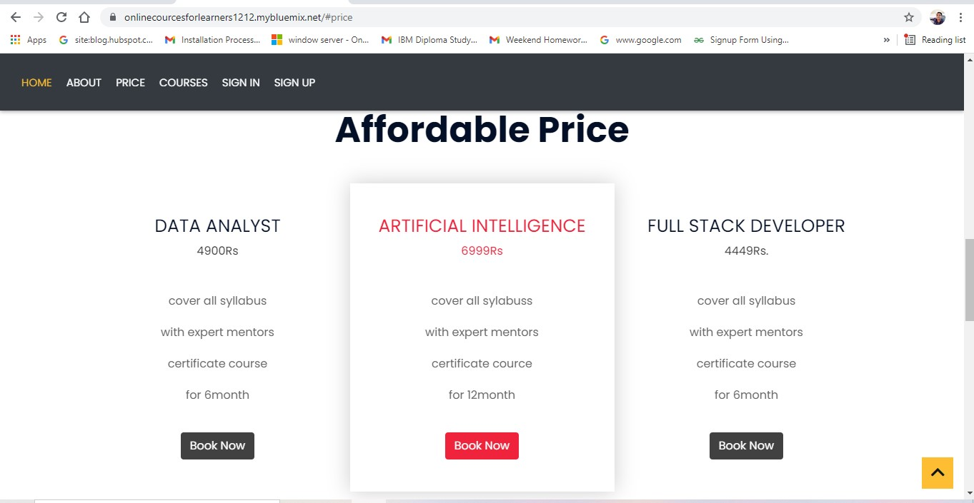

**Courses page**

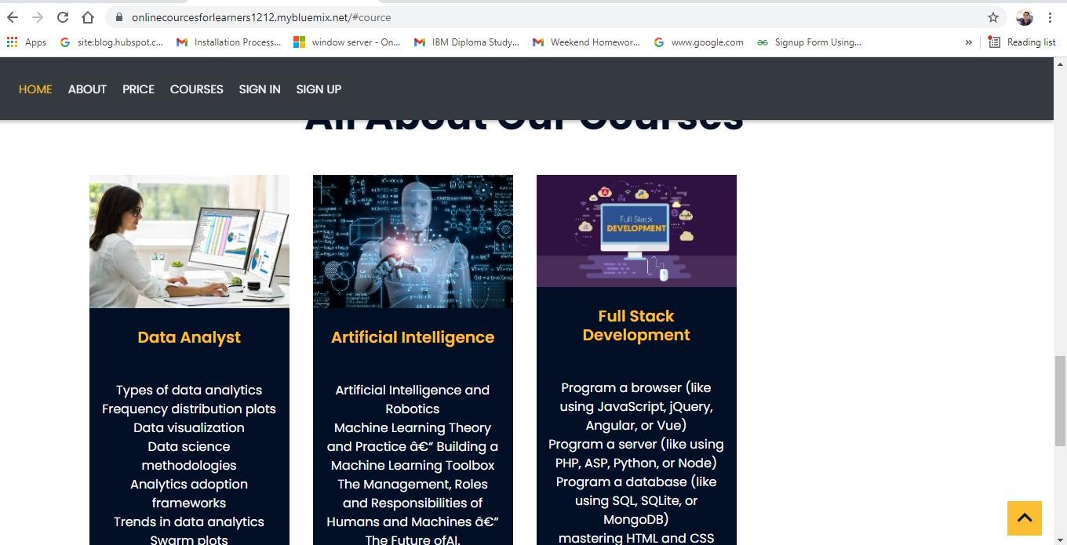

## Registration page

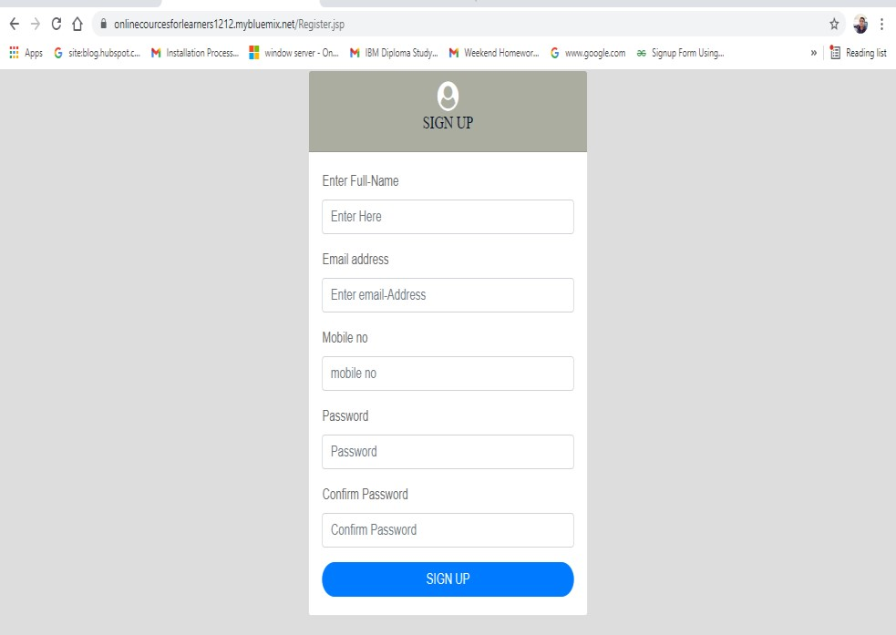

## Login page

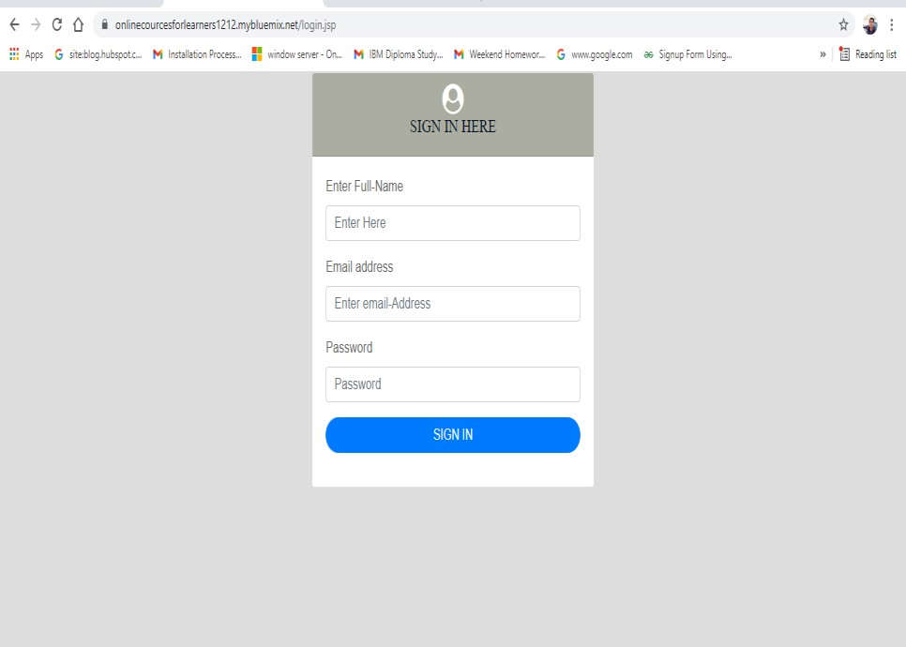

### Last page

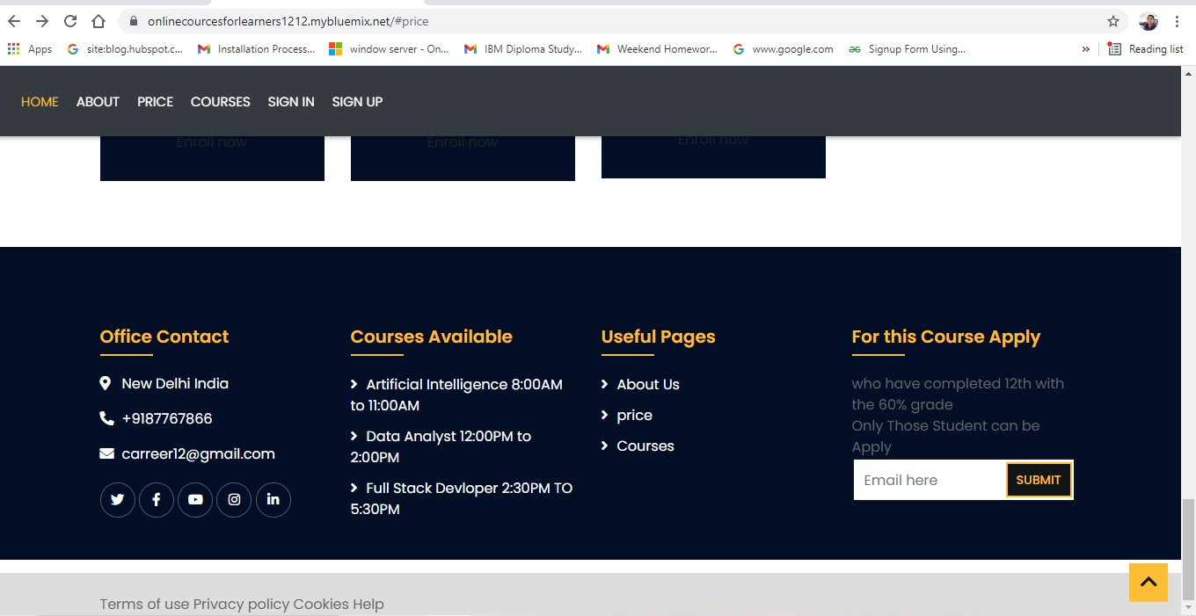

### CONCLUSION

This project is designed to meet the requirements of online re. This project can be used in restaurants after adding some more useful modules for which the restaurant is providing services. The utmost care and backup procedures must be established to ensure 100% successful implementation of the computerized restaurant website. In case of system failure, the organization should be in a position to process the transaction with another organization. Nowadays restaurants are providing many other facilities. This project can also be improved with the improvement in the restaurant. Thus, with such improvements, this software has bright future scope of being implemented practically.

E-Learning represents an innovative shift in the field of learning, providing rapid access to specific knowledge and information. It offers online instruction that can be delivered anytime and anywhere through a wide range of electronic learning solutions such as Web-based courseware, online discussion groups, live virtual classes, video and audio streaming, Web chat, online simulations, and virtual mentoring. E-Learning enables organizations to transcend distance and other organizational gaps by providing a cohesive virtual learning environment. Companies must educate and train vendors, employees, partners, and clients to stay competitive and E-Learning can provide such just-in-time training in a cost-effective way. Developing and deploying effective eLearning programs may require products and services supplied by a variety of vendors, leaving one to connect the dots. One way to start is to define the goals of the desired learning solution.

### REFERENCES

<https://www.w3schools.com/howto/howto_js_redirect_webpage.asp>[https://www.simplilearn.com/artificial-intelligence-masters-program-trainingcourse#what-skills-will-be-covered-in-this-artificial-intelligence-course](https://www.simplilearn.com/artificial-intelligence-masters-program-training-course#what-skills-will-be-covered-in-this-artificial-intelligence-course)

<https://www.ibm.com/>

THANK

YOU………